Project Report

|  |  |
| --- | --- |
| **Course Name (NICF)** | **NICF Diploma in Business Analytics** |
| Product Name (Marketing & Sales) | Professional Diploma in Data Science |
| **Module Name (NICF)** | **NICF Data Science Essentials** |
| Product Name (Marketing & Sales) | Data Science Essentials |

|  |  |  |  |
| --- | --- | --- | --- |
| Student name | | Assessor name | |
| Syed Shabana | | Ryan | |
| Date issued | Completion date | | Submitted on |
| 25/02/2021 | 27/02/2021 | | 27/02/2021 |
|  | |  | |
| Project title | Student Registration Form Development | | |

|  |
| --- |
| Learner declaration |
| I certify that the work submitted for this assignment is my own and research sources are fully acknowledged.  Student signature: Date:27/02/2021 |

Content

1. Project Overview 3
2. Project Technical Environment 3,4
3. Analytical Technique & Tools used 4-6
4. Data Science Project Team – Roles and Responsibilities Table 6-8
5. Activity 1: Activity Summary 8-13
6. Activity 2: Flight Dataset- An Overview 13-16
7. Screenshots of each task of Activity 3 17-18
8. Screenshots of each task of Activity 4 19-21
9. Screenshots of each task of Activity 5 21-25
10. Screenshots of each task of Activity 6 25-26
11. Screenshots of each task of Activity 7 26-28
12. Screenshots of each task of Activity 8 29-31
13. Screenshots of each task of Activity 9 32-34
14. Screenshots of each task of Activity 10 34-39
15. Screenshots of each task of Activity 11 39-40
16. Screenshots of each task of Activity 12 40-44
17. Project Overview: Describe the Project with summary of analytical processes and project outcomes (Explain the Project in your own words in 15 – 20 lines)

This project is about the flight delay on arrival. Delay is a key point in air transportation activity. As a performance metric, it affects common policy concerns. Delay impacts passenger satisfaction and imposes costs. The complexity that sets in for the air traffic manager is how to mitigate delay, especially in an environment with several stakeholders.

By using machine learning algorithm, we can predict the arrival delay based on different conditions like

* Which state has highest arrival delays
* Arrival delays are more or departure delays are more
* how many minutes delay for each flight on different times
* In which month most delays happening
* During morning delays happening more or in the evening time

We collected flight delay dataset from Azure Machine Learning Studio. It consists of 2719418 Rows and 14 columns. It consists of different fields like Year, Month, Day of month, Day of week ,OriginAirportID, DestinationAirportID , CRSDepTime ,DepDelay, DEpDel15,CRSArrTime,ArrDelay,ArrDelay,ArrDel15,Cancelled.From this dataset we are predicting ArrDelay using AML machine learning algorithm and by using Python also. First we identified dependent and independent variables and then by using boosted Regression algorithm predicted value.

To develop machine learning algorithm we are using Boosted Decision Tree regression algorithm. Boosted Decision Tree regression algorithm is a regression algorithm that models the probability of the output class . It estimates relationship between a dependent variable (target/label) and one or more independent variable (predictors).

1. **Project Technical Environment:** (Describe the Microsoft Azure Machine Learning Platform)

In this project we are using

* Azure Machine Learning Platform for building the algorithm
* For visualisation used Python

Microsoft Azure Machine Learning:

Azure Machine Learning can be used for any kind of machine learning, from classical ml to deep learning, supervised ,and unsupervised learning. In AML we can write Python or R code with SDK or work with no-code/low-code options. We can build, train, and track machine learning and deep-learning models in an Azure Machine Learning Workspace

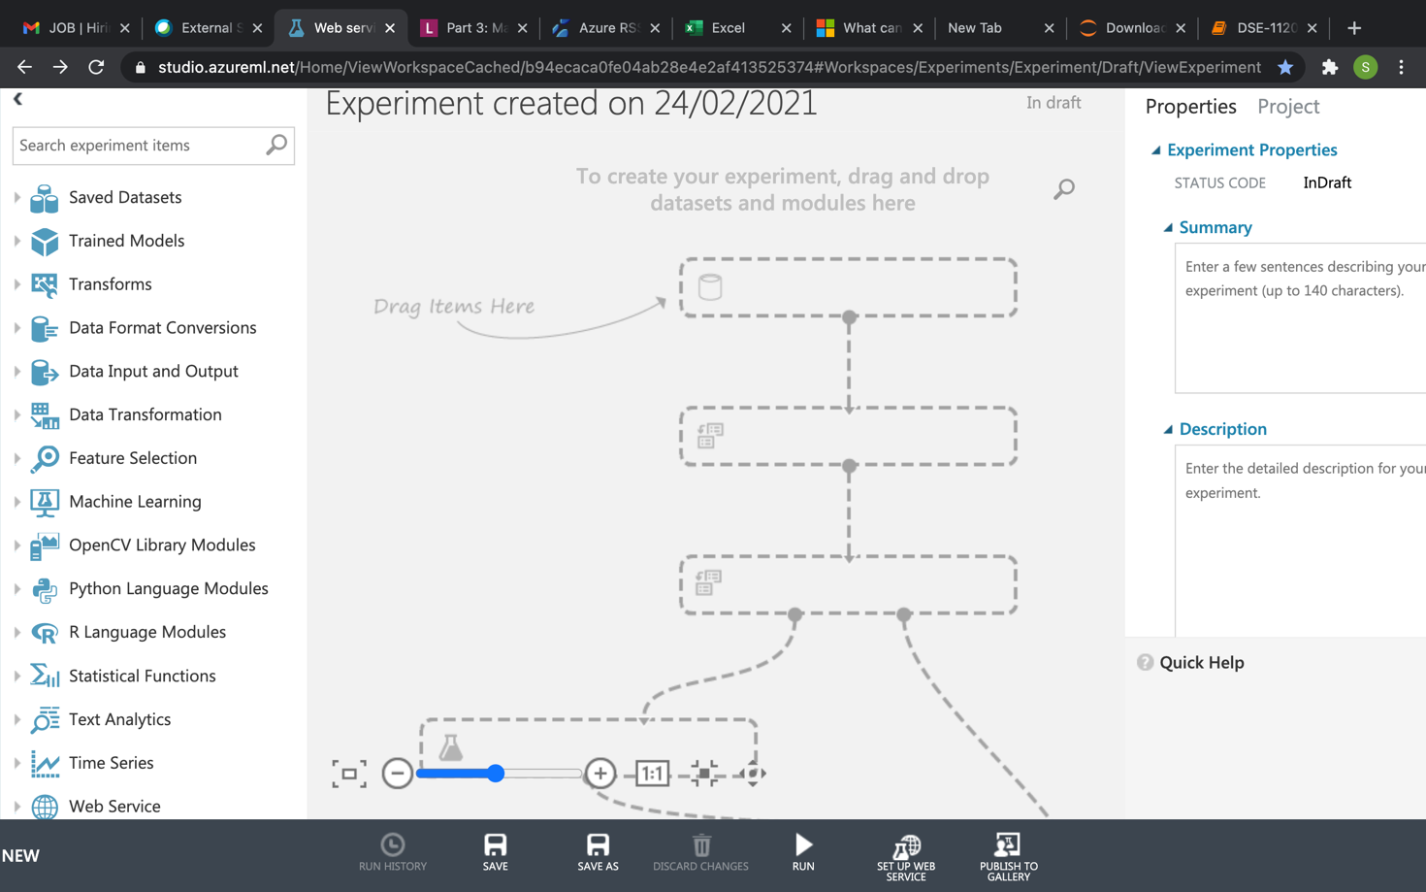

In azure ML we will have 3 panes. Left side of the pane consists of module pallet. It consists of datasets, trained models, transformations, data input and output python, R function modules which are used to build the experiment. Middle pane is nothing but experiment pane where we can build experiments. To build experiment we need to drag and drop modules from the left side of the pane to the middle pane and create model. Right side of the pane is properties pane where the properties of the module are set in this pane. Down side we have save and run buttons. After creating model we can run the model by using run and deploy the web service also. In the experiment pane after creating the model we can visualize the result also by right clicking at the node.

For Python execution used Jupyter notebook. In jupyter notebook used different types of libraries like matplotlib, seaborn, pandas, Numpy and sklearn.

1. **Analytical Technique & Tools used :** Describe the Analytical Technique (Regression) and Tools used in the Project

For this Project, we are using boosted decision tree regression analysis. We have three types regressions . One is Linear Regression, decision trees and boosted decision trees.

We all use Decision Tree technique on daily basis to plan our life, we just don’t give a fancy name to those decision-making process. Boosting is one of several classic methods for creating ensemble models, along with bagging, random forests, and so forth. In Azure Machine Learning, boosted decision trees use an efficient implementation of the MART gradient boosting algorithm. Gradient boosting is a machine learning technique for regression problems. It builds each regression tree in a step-wise fashion, using a predefined loss function to measure the error in each step and correct for it in the next. Thus the prediction model is actually an ensemble of weaker prediction models. The gradient boosting method can also be used for classification problems by reducing them to regression with a suitable loss function. In classification we use [Two-Class Boosted Decision Tree](https://docs.microsoft.com/en-us/azure/machine-learning/algorithm-module-reference/two-class-boosted-decision-tree).

In regression problems, boosting builds a series of trees in a step-wise fashion, and then selects the optimal tree using an arbitrary differentiable loss function . Businesses use these supervised machine learning techniques like Decision trees to make better decisions and make more profit. Decision trees have been around for a long time and also known to suffer from bias and variance. We will have a large bias with simple trees and a large variance with complex trees.

**Ensemble methods**, which combines several decision trees to produce better predictive performance than utilizing a single decision tree. The main principle behind the ensemble model is that a group of weak learners come together to form a strong learner.

Few techniques to perform ensemble decision trees:. Bagging , Boosting

Bagging (Bootstrap Aggregation) is used when our goal is to reduce the variance of a decision tree. Here idea is to create several subsets of data from training sample chosen randomly  with replacement. Now, each collection of subset data is used to train their decision trees. As a result, we end up with an ensemble of different models. Average of all the predictions from different trees are used which is more robust than a single decision tree.

Random Forest is an extension over bagging. It takes one extra step where in addition to taking the random subset of data, it also takes the random selection of features rather than using all features to grow trees. When you have many random trees. It’s called Random Forest

steps taken to implement Random forest:

* Suppose there are N observations and M features in training data set. First, a sample from training data set is taken randomly with replacement.
* A subset of M features is selected randomly, and whichever feature gives the best split is used to split the node iteratively.
* The tree is grown to the largest.
* Above steps are repeated and prediction is given based on the aggregation of predictions from n number of trees.

**Advantages of using Random Forest technique:**

Handles higher dimensionality data very well.

Handles missing values and maintains accuracy for missing data.

**Disadvantages of using Random Forest technique:**

Since final prediction is based on the mean predictions from subset trees, it won’t give precise values for the regression model.

**Boosting** is another ensemble technique to create a collection of predictors. In this technique, learners are learned sequentially with early learners fitting simple models to the data and then analyzing data for errors. In other words, we fit consecutive trees (random sample) and at every step, the goal is to solve for net error from the prior tree.

When an input is misclassified by a hypothesis, its weight is increased so that next hypothesis is more likely to classify it correctly. By combining the whole set at the end converts weak learners into better performing model.

**Gradient Boosting** is an extension over boosting method.

Gradient Boosting= Gradient Descent + Boosting.

It uses gradient descent algorithm which can optimize any differentiable loss function. An ensemble of trees are built one by one and individual trees are summed sequentially. Next tree tries to recover the loss (difference between actual and predicted values).

**Advantages of using Gradient Boosting technique:**

Supports different loss function.

Works well with interactions.

**Disadvantages of using Gradient Boosting technique:**

Prone to over-fitting.

Requires careful tuning of different hyper-parameters

1. Data Science Project Team – Roles and Responsibilities Table

Activity1:Task1

Data science is the process of using algorithms, methods, and systems to extract knowledge and insights from structured and unstructured data. It uses analytics and machine learning to help users make predictions, enhance optimization, and improve operations and decision making .Today’s data science teams are expected to answer many questions. Business demands better prediction and optimization based on real-time insights backed by tools like these.

The data science lifecycle starts with gathering data from relevant sources, cleaning it and putting it in formats that machines can understand. In the next phase, statistical methods and other algorithms are used to find patterns and trends. Then models are programmed and built to predict and forecast; finally, results are interpreted.

The opportunity here is massive. The automation of tedious data science tasks such as data preparation, and the empowerment of analysts without coding experience to build models, keeps business agile and innovative. Automating the data science lifecycle frees expert data scientists to address the more interesting and innovative aspects of the field. Human intelligence combined with data science technology and automation helps a business extract greater value from data.

Data scientists work closely with business stakeholders to understand their goals and determine how data can be used to achieve those goals. They design data modelling processes, create algorithms and predictive models to extract the data the business needs, and help analyze the data and share insights with peers. While each project is different, [the process for gathering and analyzing data](https://www.northeastern.edu/graduate/blog/data-analysis-project-lifecycle/) generally follows the below path:

1. Ask the right questions to begin the discovery process

2. Acquire data. Collect and review data

3. Process and clean the data. After receiving data , data scientist will cleanse data.

4. Integrate and store data

5. Initial data investigation and exploratory data analysis

6. Choose one or more potential models and algorithms

7. Apply data science techniques, such as machine learning, statistical modelling, and artificial intelligence

8. Measure and improve results

9. Present final result to stakeholders

10. Make adjustments based on feedback

11. Repeat the process to solve a new problem

Data Science project team members and their roles

## **Data Engineer**

Data engineers make the appropriate data accessible and available for data science efforts. They design, develop, and code data-focused applications that capture data, as well as clean the data. This role also helps to ensure consistency of datasets (e.g., meaning of attributes across datasets).

## **Data Science Architect**

Data science architects design and maintain the architecture of data science applications and facilities. In other words, this role creates and manages relevant data models, data storage systems and processes workflows. In conjunction with the Data Engineer, they manage and merge large amounts of data and their related sources.

## **Data Science Developer**

Data Science Developers design, develop, and code large data (science) analytics applications to support scientific or enterprise/business processes. This role enables models to be deployed (i.e., use a model in production) and requires some expertise in data science, as well as knowledge of how to effectively develop software applications. Sometimes this role is known as an ML engineer.

## **Product Owner**

The product owner is the central point of product leadership – the person who decides which features and functionality to build, the order in which to build them, and what aspects of them to observe and analyze. The product owneris responsible for prioritizing what work gets done, ensuring that each work item is clearly defined from a business context, and that the upcoming work and priorities of the team are visible and transparent. In addition, the product owner must agree that the tasks in the done column are actually done. In short, the product owner represents all the stakeholders for the project. While a product owner is often the product manager, it is possible to have separate these roles, in that the Product managers has a more strategic focus on the product’s vision, company objectives, and the market (as compared to a product owners which are more tactical and directly involved within the day-to-day data science team by translating a product manager’s strategy into actionable tasks.

## **Data/Business Analyst**

Data/Business Analysts analyze a large variety of data to extract information about system, service, or organization performance and present them in usable/actionable form. They better shape a problem for the data scientist to explore.

## **Process Master**

The process master acts as a coach, facilitator, impediment remover as well as helping everyone involved understand and embrace the project values, principles, and practices to aid the organization obtain exceptional results.

## **Subject Matter Expert**

Subject matter experts are people with extensive knowledge of how to apply the analytics within a specific organizational context. This role is accountable to ensure the desired insights are actionable.

Clearly, larger data science projects are a team effort that requires effective coordination among various roles with diverse skillsets.

1. Activity 1: Activity Summary

**Task 2:** Review the Data Cleansing, Exploration and Machine learning activities below

**Data Cleansing:**

Once we received we first need to understand the data and then start the cleaning process. The main aim of **Data Cleaning** is to identify and remove errors & duplicate **data**, in order to create a reliable dataset. This improves the quality of the training **data** for analytics and enables accurate decision-making

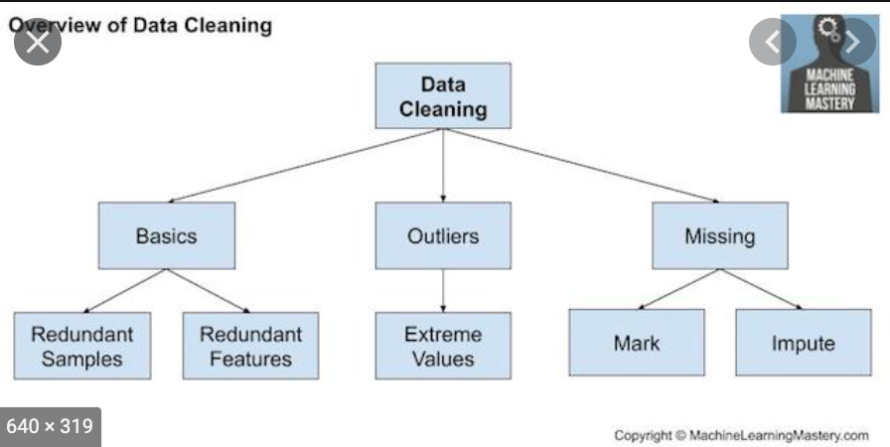

The cleaning process includes the following steps

* Check for the redundant samples and redundant features. If there are any duplicate rows in the dataset first, we will remove those rows in the cleaning process. Same for duplicate features also
* Check for the outliers and extreme values by using boxplot or scatter plot and then will remove those values
* Check for the missing values like the rows with nan, or like 999 or empty space. Those type of rows has to be removed or by replacing with 0 or some other values. By using ffill and bfill we can replace the empty value with forward number or by using interpolate also can replace the values.

The following steps are for data cleansing for FlighDelay dataset.

* Log in to Azure Machine Learning portal
* Create Flight challenge experiment
* Load Flight delays and Airport codes dataset from Azure AM sample dataset
* Visualize the Flight delays dataset. The dataset consists of Year, Month, DayofMonth, DayOfWeek, OriginAirportId, DestAirportID, CRSDepTime, DepDelay, DepDel15, CRSArrTime, ArrDelay, ArrDelay, ArrDel15, Cancelled columns with 2719418 rows
* Visualize Airport codes dataset and it consists of airport_id, City, State, Name and 365 rows
* Created first left outer join on OriginAirportID and Airport_id
* Created second left outer join on DestAirportID and Airport_id
* Removed the duplicate rows if they have missing values.
* Replaced missing values in a row with zero.

**Data exploration**

**Data exploration is** the first step of **data** analysis used to explore and visualize **data** to uncover insights from the start or identify areas or patterns to dig into more. Using interactive dashboards and point-and-click **data exploration**, users **can** better understand the bigger picture and get to insights faster.

A Machine Learning project is as good as the foundation of data on which it is built. In order to perform well, machine learning data exploration models must ingest large quantities of data, and model accuracy will suffer if that data is not thoroughly explored first.

Data exploration steps to follow before building a machine learning model include:

# Outliers in data:

Outliers, i.e., observations that have relatively large or small value compared to the majority of observations, may have a large or dominating impact on experiment results. Although techniques to deal with them may vary, it is important to know whether they exist. Boxplot is the main tools for outlier detection.

# **Homogeneity in variance:** Homogeneity in variance is an important assumption in analysis of variance. Regression related models and in multivariate techniques. It means the variance of the feature variables needs to be similar. This can be validated by exploring the residuals of the model, i.e., by plotting residuals vs. fitted values, and the variation of the residuals should be similar in the plots.

# **Normally distributed data:** Various statistical techniques assume normality, such as linear regressions and t-tests. Histograms can be used to show data distributions.

# Zeros (missing value) in the data: Zero (or null) data will make the analysis more complicated. They might be labeled incorrectly as similar since they are all zeros.

# Collinearity in covariates: If collinearity is ignored, one is likely to end up with a confusing statistical analysis in which nothing is significant. However, when one covariate is dropped, the others might become significant. Ways to detect collinearity include calculating variance inflation factors (VIF), pairwise scatter-plots comparing covariates, correlation coefficients or a PCA biplot applied on all covariates.

# Interaction between variables:

Interaction means the relationship of variables will change according to the value of other variables. This type of information can be found by observing the weights of the variables when performing linear regression.

# Independence in the dataset: Data points in a dataset should be drawn independently. This can be analyzed by modeling any spatial or temporal relationships, or by nesting data in a hierarchical structure.

These points provide guidelines for data exploration. They motivate us to dive into some common techniques that are easy to perform but address important aspects in the above protocol.

Here are the steps that followed to explore data. For exploring data, we used Python matplotlib and seaborn.

1. By using describe () function displayed the summary statistics for ArrDelay column.
2. By using boxplot checked the range of values and outliers of ArrDelay feature column
3. By using histogram checked the distribution of ArrDelay and calculated range.
4. Plotted conditioned histograms and compared numeric columns like DepDelay (how many minutes late), CRSDepTime Scheduled departure time 24 hours format), ArrDel15(Binary column indicating arrival delay was 15 mins late or more than 15 minutes), Day of month, Day of week and month.
5. Plotted scatter plot on DepDelay',' CRSArrTime',' CRSDepTime',' DayofMonth', 'DayOfWeek', 'Month' vs ArrDelay to check the relationship between the variables.

**Machine Learning:**

After data prepared, we can perform machine learning, like modeling, model training and tuning, prediction and model deployment. Various types of models have been used and researched for machine learning systems. In this step we will choose the model and do the prediction. Split the data, Apply algorithm, train and score the model to predict.

For flight delay experiment performed following Machine Learning activities.

# Performed normalisation by using ZScore transformation

# Split the data like 70% for training and 30% for testing

# Scored the model and added scored label to the resulting dataset

# Evaluated the model by using Coefficient and Root Mean Squared Error.

**Task 3:**

Before cleaning data dataset contains 2719418 rows. After cleaning the duplicate rows and replaced the NA values with 0.

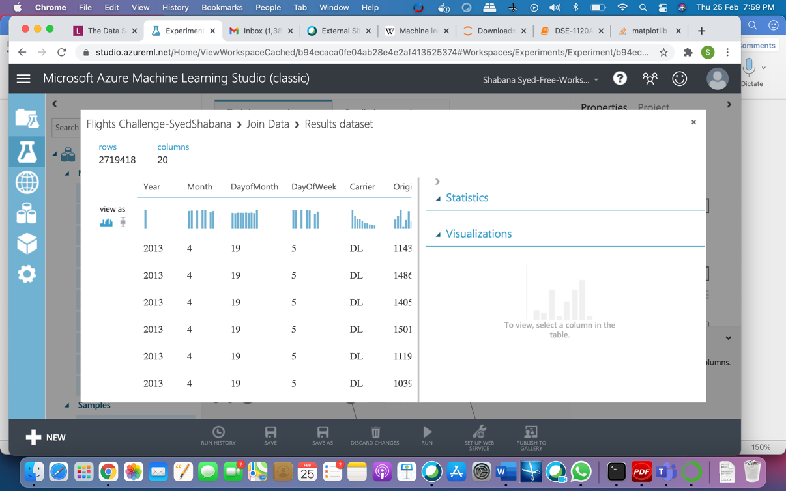

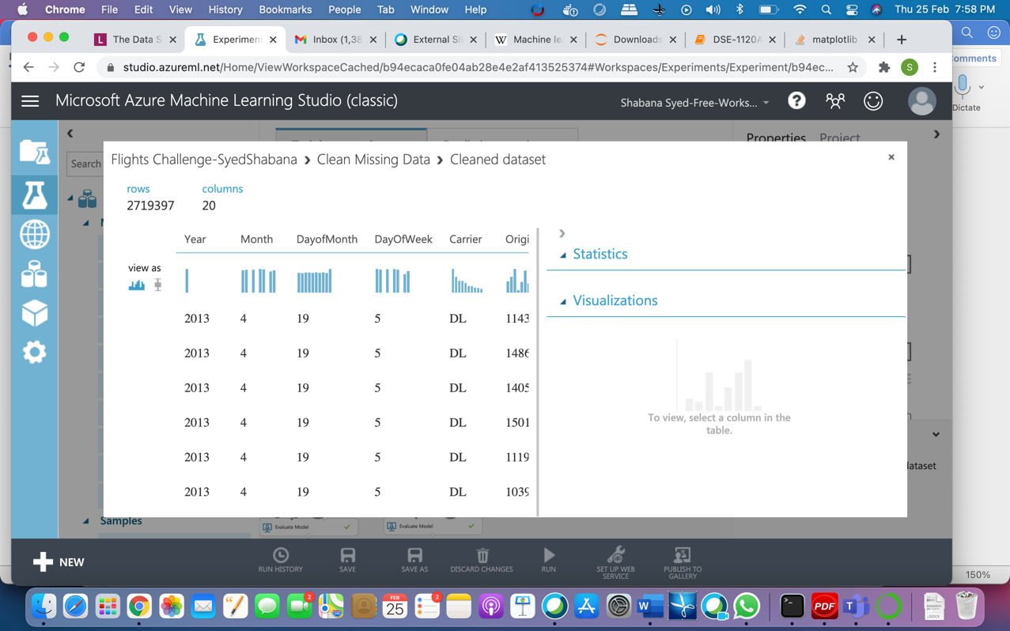

Exploration:

* Checked the mean, standard deviation and quantile values have been checked for ArrDelay column as part of data exploration.
* Plotted box plot to check the outliers for ArrDelay column which is our prediction column. If we see the graph shows that it has many outliers, and the median and mean values are near to 0.
* Plotted scatter plot to check the relation between the independent and dependent variable. Arrdelay and Depdelay have strong correlation

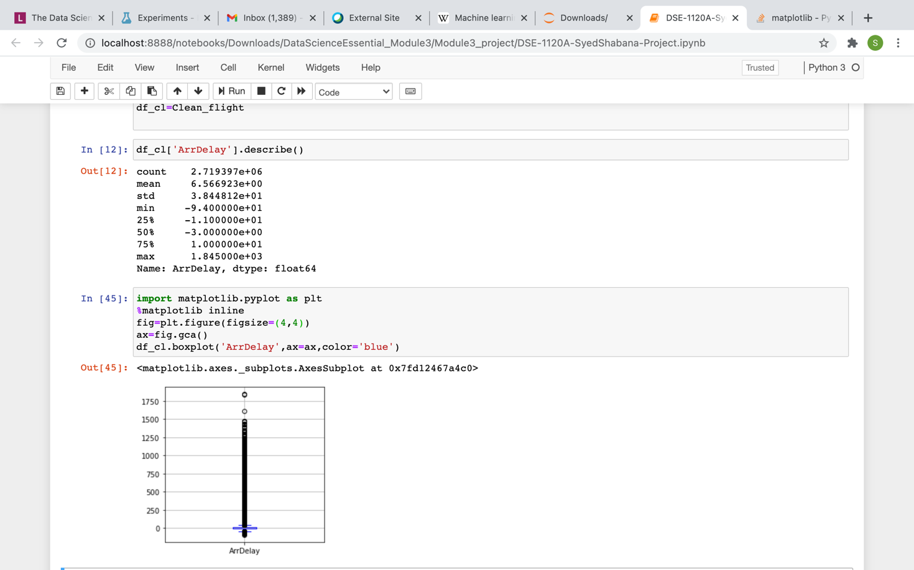

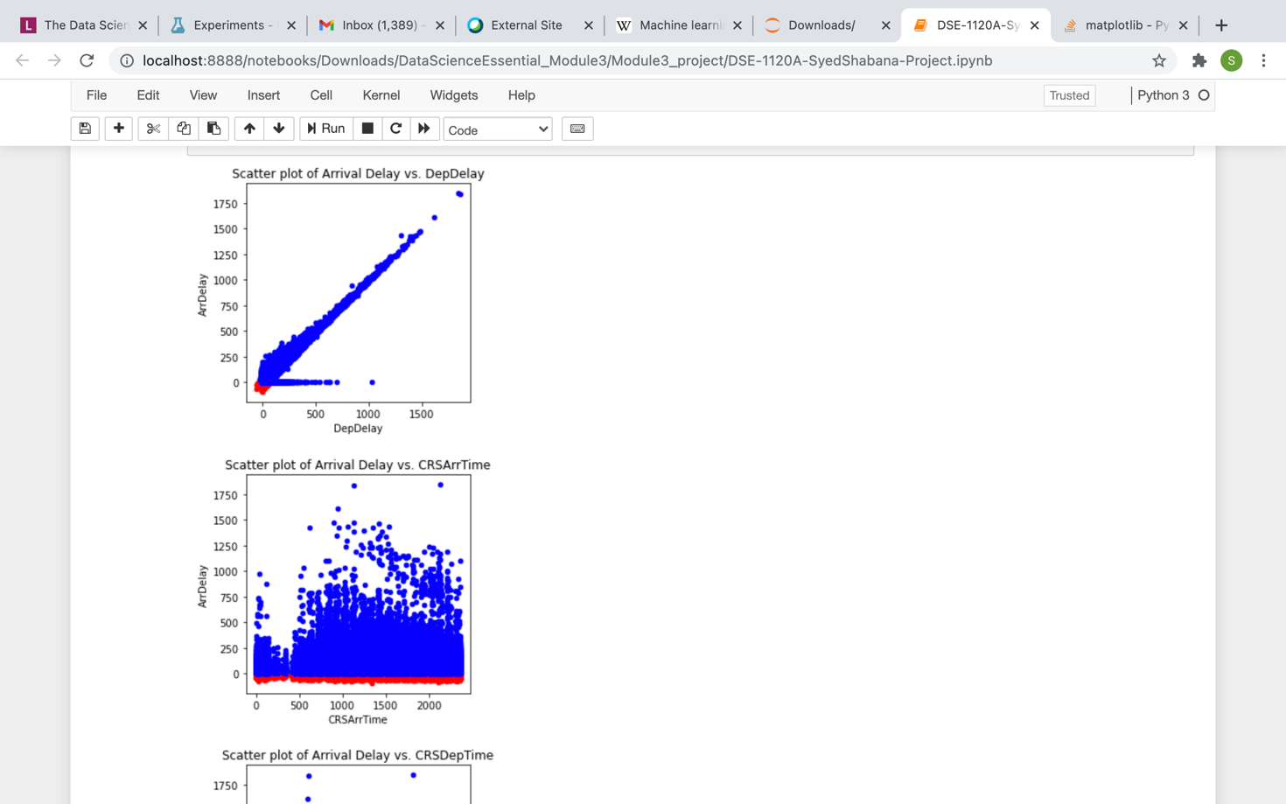

In machine learning evaluated the model and we can see the coefficient value is 0.8889822.Which is nothing but near to 1.So the model is perfect model with Mean Absolute error 8.6096.

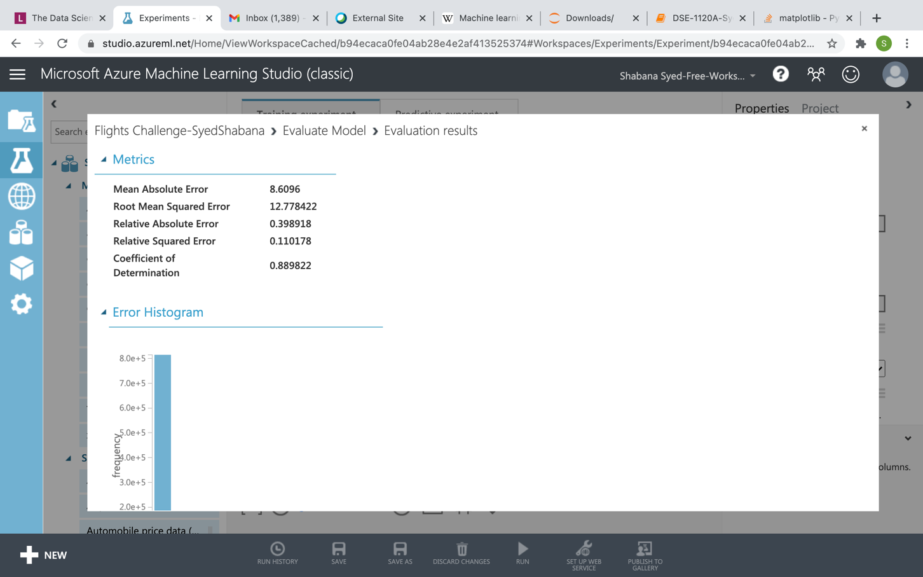

1. Activity 2: Flight Dataset- An Overview

K-means is one of the simplest and the best known unsupervised learning algorithms, and can be used for a variety of machine learning tasks, such as [detecting abnormal data](https://msdn.microsoft.com/magazine/jj891054.aspx), clustering of text documents, and analysis of a dataset prior to using other classification or regression methods. To create a clustering model, you add this module to your experiment, connect a dataset, and set parameters such as the number of clusters you expect, the distance metric to use in creating the clusters, and so forth.

After you have configured the module hyperparameters, connect the untrained model to the Train Clustering Model or the Sweep Clustering Modules to train the model on the input data that you provide. Because the K-means algorithm is an unsupervised learning method, a label column is optional.

* If your data includes a label, you can use the label values to guide selection of the clusters and optimize the model.
* If your data has no label, the algorithm creates clusters representing possible categories, based solely on the data.

## Understanding k-means clustering

In general, clustering uses iterative techniques to group cases in a dataset into clusters that contain similar characteristics. These groupings are useful for exploring data, identifying anomalies in the data, and eventually for making predictions. Clustering models can also help you identify relationships in a dataset that you might not logically derive by browsing or simple observation. For these reasons, clustering is often used in the early phases of machine learning tasks, to explore the data and discover unexpected correlations.

When you configure a clustering model using the k-means method, you must specify a target number k indicating the number of centroids you want in the model. The centroid is a point that is representative of each cluster. The K-means algorithm assigns each incoming data point to one of the clusters by minimizing the within-cluster sum of squares.

When processing the training data, the K-means algorithm begins with an initial set of randomly chosen centroids, which serve as starting points for each cluster, and applies Lloyd's algorithm to iteratively refine the locations of the centroids. The K-means algorithm stops building and refining clusters when it meets one or more of these conditions:

* The centroids stabilize, meaning that cluster assignments for individual points no longer change and the algorithm has converged on a solution.
* The algorithm completed running the specified number of iterations.

After completing the training phase, we can use the [Assign Data to Clusters](https://docs.microsoft.com/en-us/azure/machine-learning/studio-module-reference/assign-data-to-clusters) module to assign new cases to one of the clusters that was found by the k-means algorithm. Cluster assignment is performed by computing the distance between the new case and the centroid of each cluster. Each new case is assigned to the cluster with the nearest centroid.

# Clustering: Group Iris Data

This sample demonstrates how to perform clustering using the k-means algorithm on the UCI Iris data set. In this experiment, we perform k-means clustering using all the features in the dataset, and then compare the clustering results with the true class label for all samples. We also use the **Multiclass Logistic Regression** module to perform multiclass classification and compare its performance with that of k-means clustering.

## **Data**

We used the Iris data set, a well-known benchmark dataset for multiclass classification from the UIC repository. This dataset has 150 samples with 4 features and 1 label (the last column). All features are numeric except that the label, which is a string.

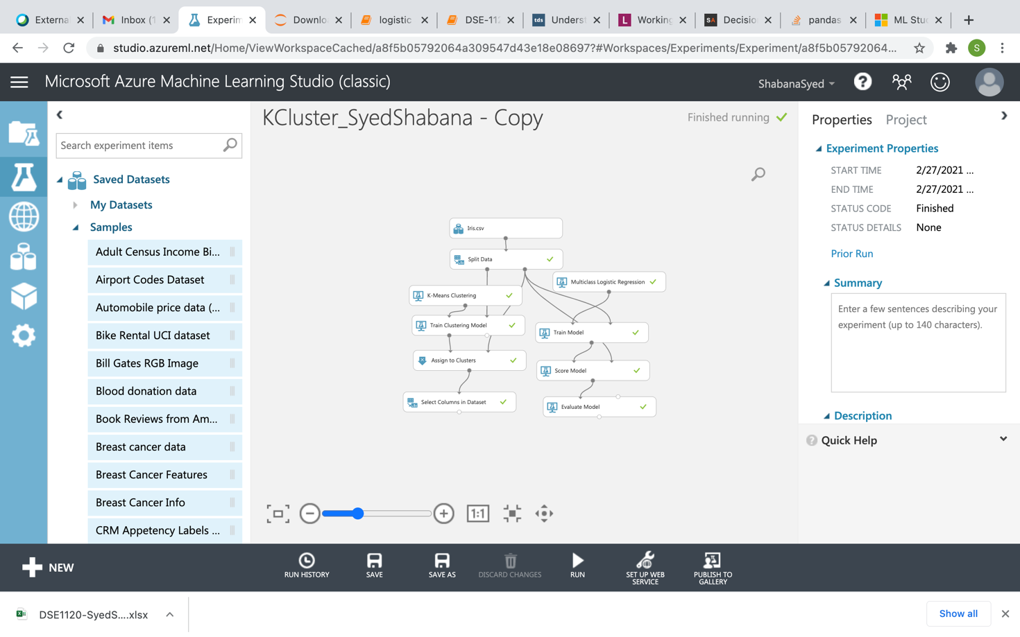

## **Data Processing**

we used the **Split** module to divide the whole data set randomly into a training and a test data set, setting the fraction of rows in the training set to 0.6. After splitting, the training data set has 90 samples and the test data set has 60 samples.

## **Model**

In this experiment, we create a model using the **K-Means Clustering**module, and compare it with the model created by using the **Multiclass Logistic Regression**module.

We use the **Train Clustering Model** to train the model, attaching the untrained clustering model from the **K-Means Clustering**module on one input, and an unlabelled dataset as the other input. You can then use the trained clustering model to return labels for the training data, by connecting the output of the **Train Clustering Model** module to the **Assign to Clusters**module.

Next we use the **Assign to Clusters** module to predict the clustering labels for the test dataset. The **Assign to Clusters** module takes the trained k-means clustering model as its first input, and the unlabelled test dataset as the second input.

Next, we build a model using the **Multiclass Logistic Regression** module, and use the **Train Model** module to train the model on the training data set. We use the **Score Model** module to create predictions on the test dataset, and use those scores as input to the **Evaluate Model** module, to compute the classification performance of the logistic regression model.

## **Results**

Here we can see the overall accuracy 0.9883.

The output from K means clustering:

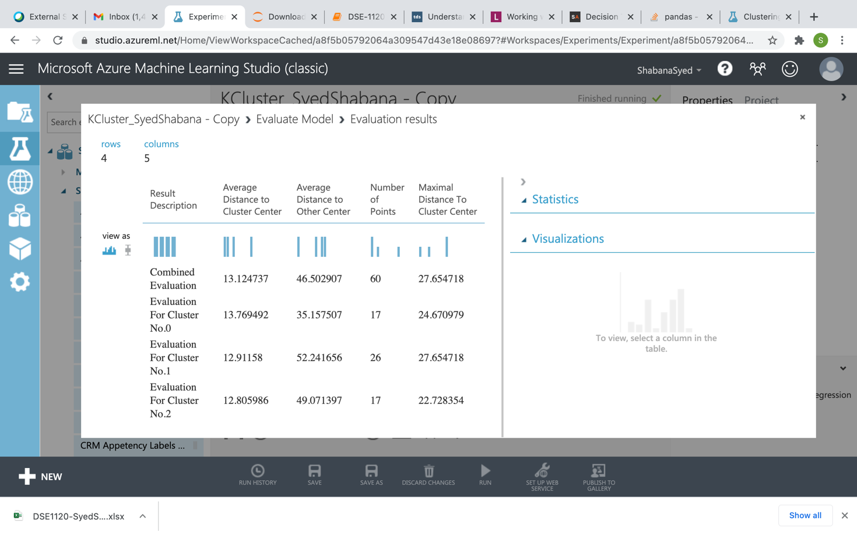

1. Screen - shots of each task of Activity 3

Task1:

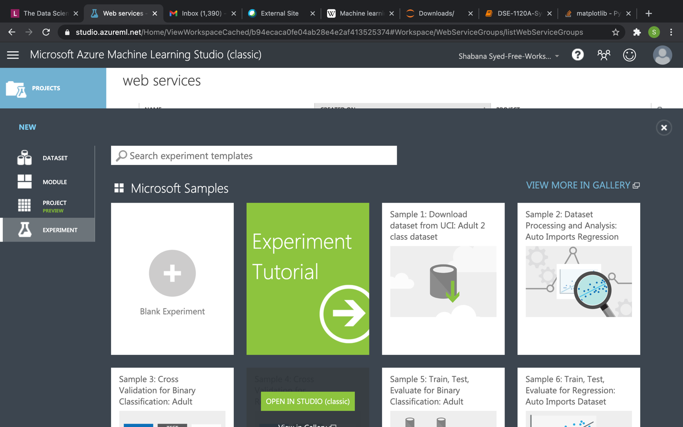

Task2:

Created new experiment with Flight Challenge and imported Flight Delays Dataset.

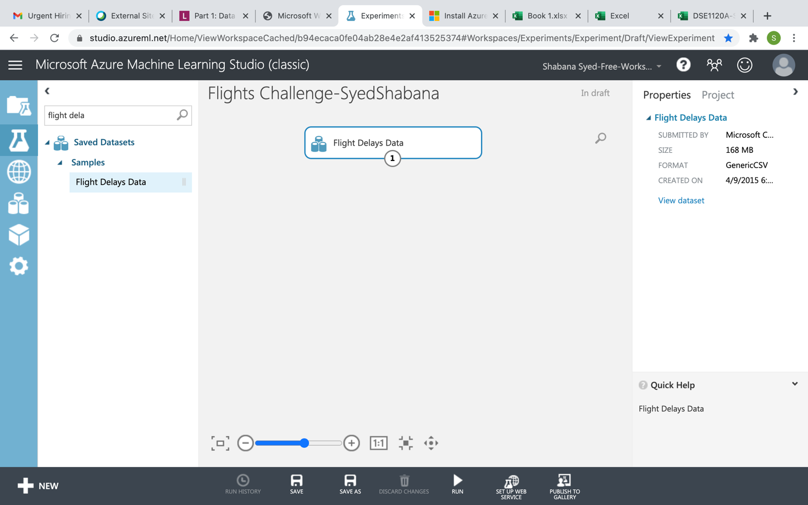

Task3:

After importing Flight Delays dataset visualized the data from Flight Delays dataset. It consists of 2719418 rows and 14 columns.

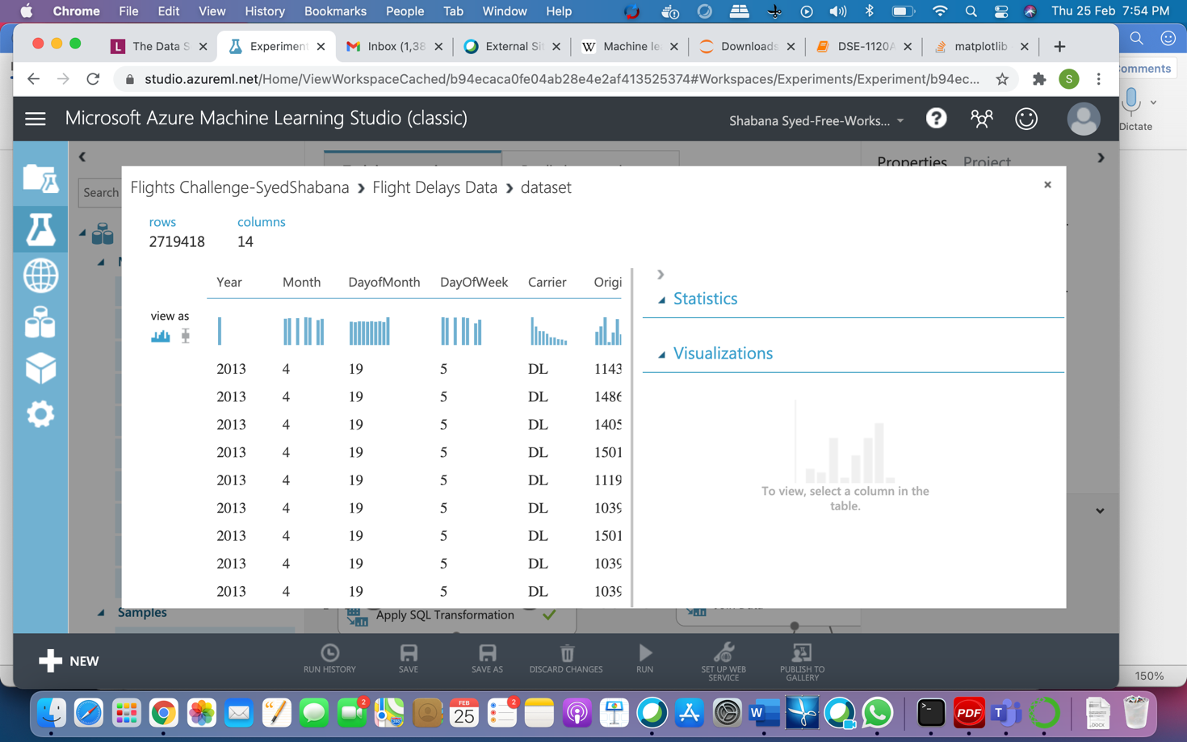

Task4:

Here we are checking the ArrDelay feature statistics like mean, median etc. We can clearly see the mean for ArrDelay column is 6.6377.There are 2719418 rows.

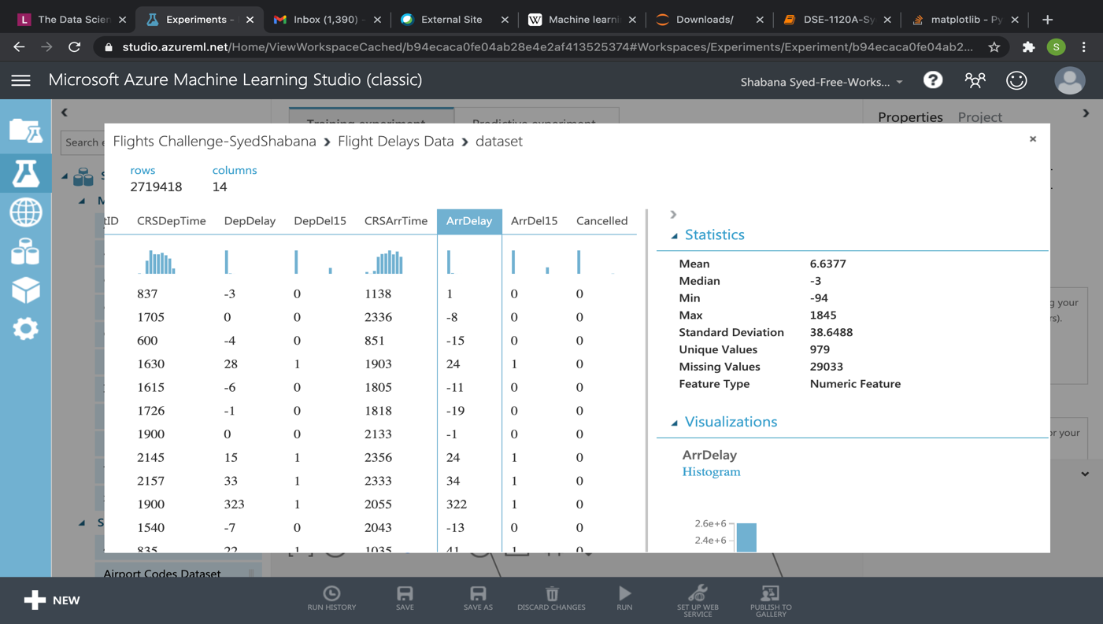

1. Screenshots of each task of Activity 4

**Task 1:**

* Read the airport codes dataset. By using edit metadata changed Airport codes data set column names for better understanding. After that performed inner join operation by using OriginAirportID key from Flights Delay and Airport_id key from Airport codes dataset. After the join the resulting data consists of all the values from left table and matching values from the right table.
* By using edit metadata changed Airport codes data set column names as destination columns for better understanding From the resulting dataset again performed left outer join operation by using DestAirportID key from resulting dataset and Airport_id key from Airport codes dataset. Now my resulting data set consists of all the values from my resulting dataset and matching values from the Airport codes dataset.
* After the second join we can see that most frequently occurring destination airport in the dataset is - Hartsfield-Jackson Atlanta International

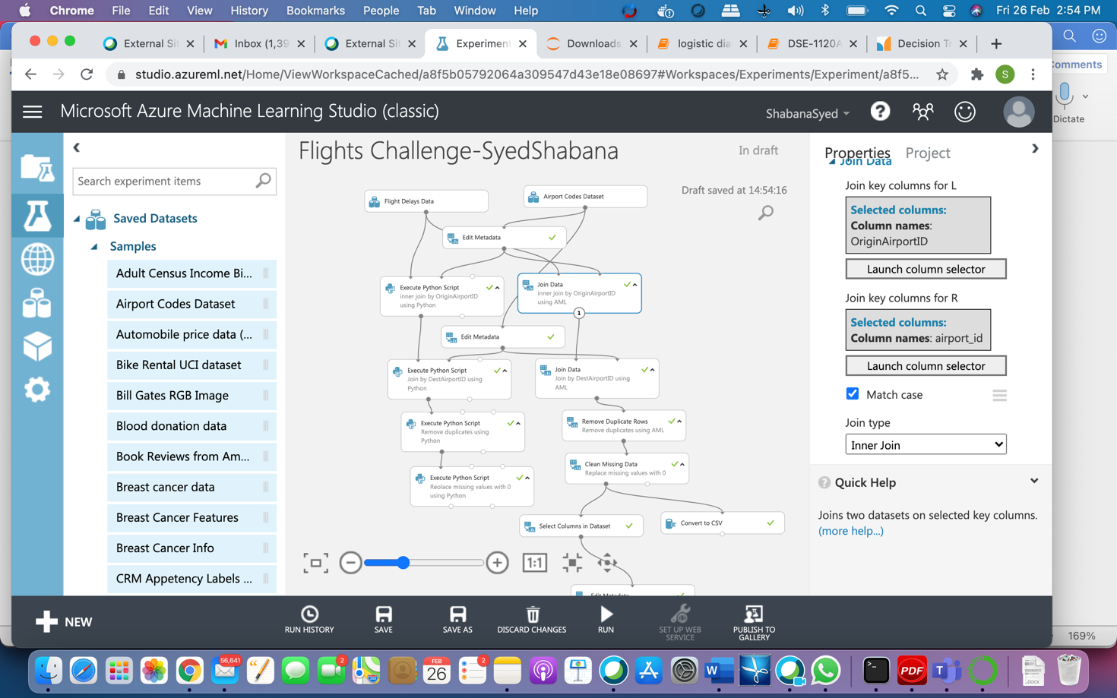

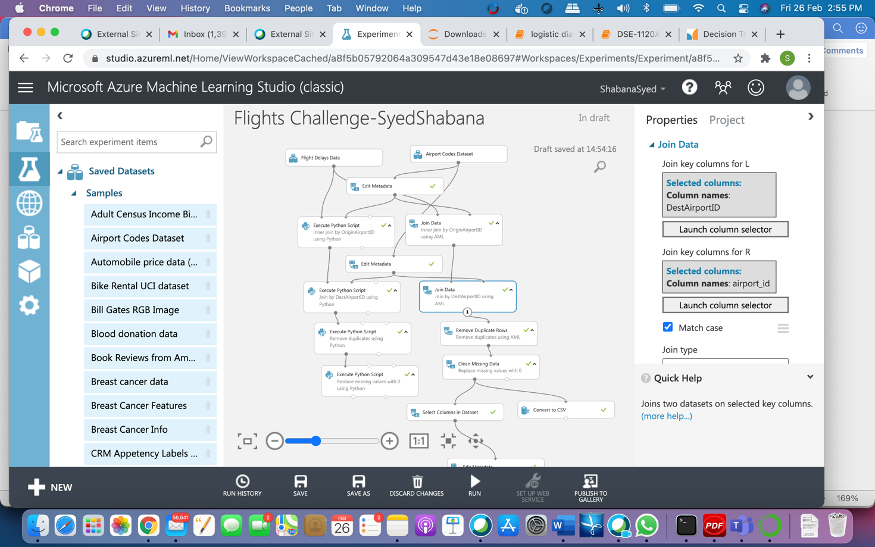

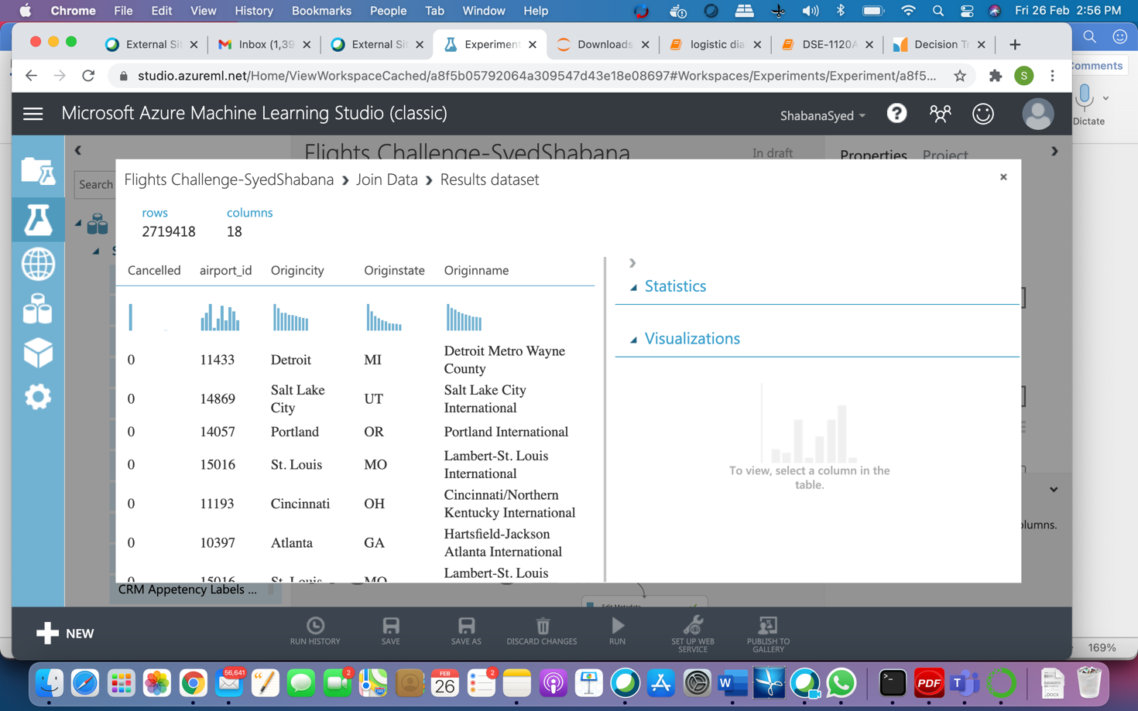

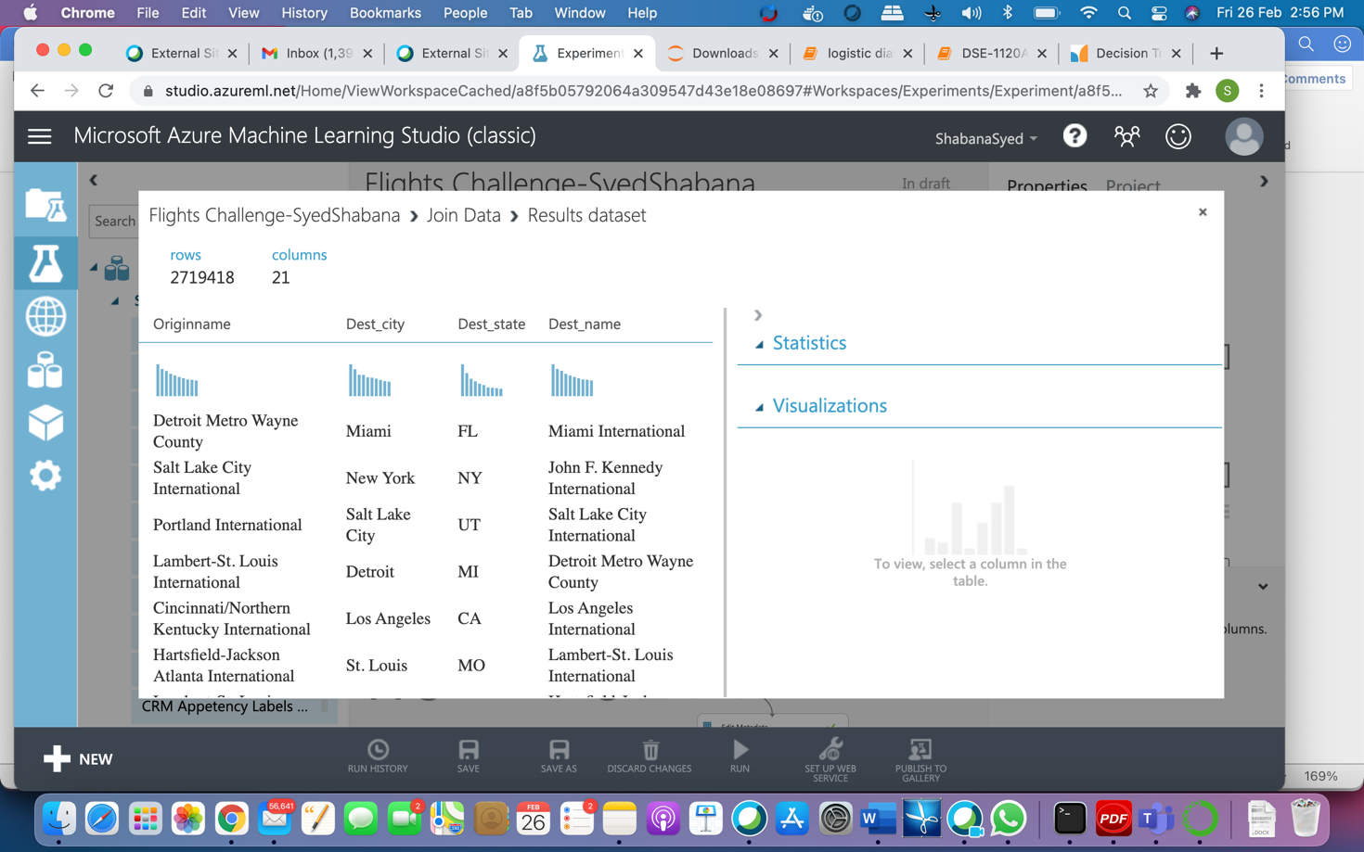

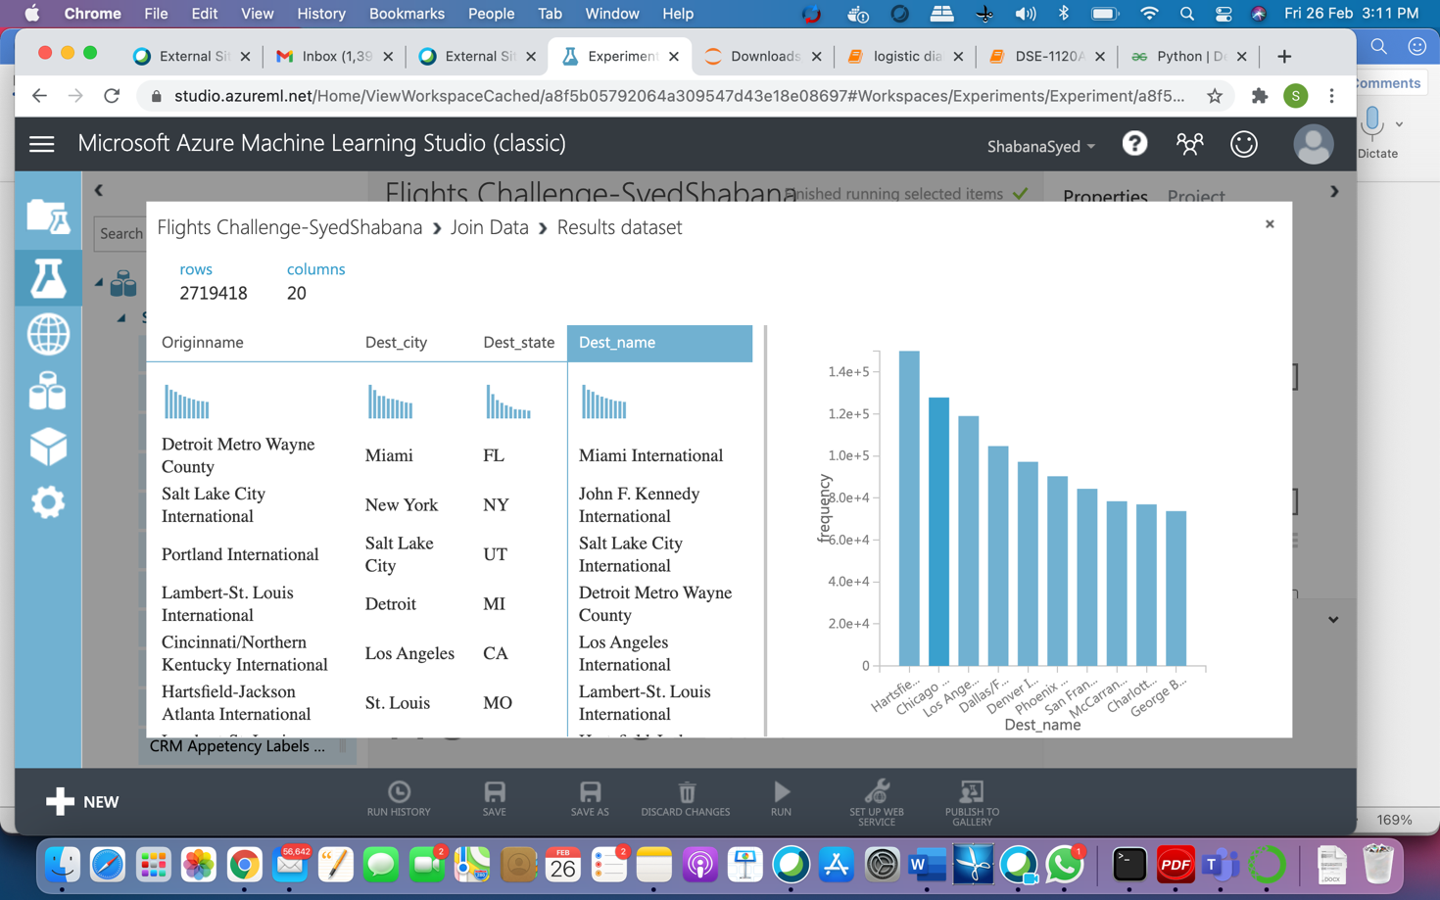

1. Screenshots of each task of Activity 5

Task1: In this task we are removing duplicate rows for the selected features or fields. The columns that I used for deleting duplicates are Year, Month, DayofMonth, DayofWeek, OriginAirportID, DestAirportID, CRSDepTime, CRSArrTime, Carrier. As we can see after join our dataset contain 2719418 rows. After removing duplicates, the resulting dataset contains 2719317 rows. If we have duplicates and missing values in dataset it will cause bias to our model during prediction. For that purpose, need to remove duplicates.

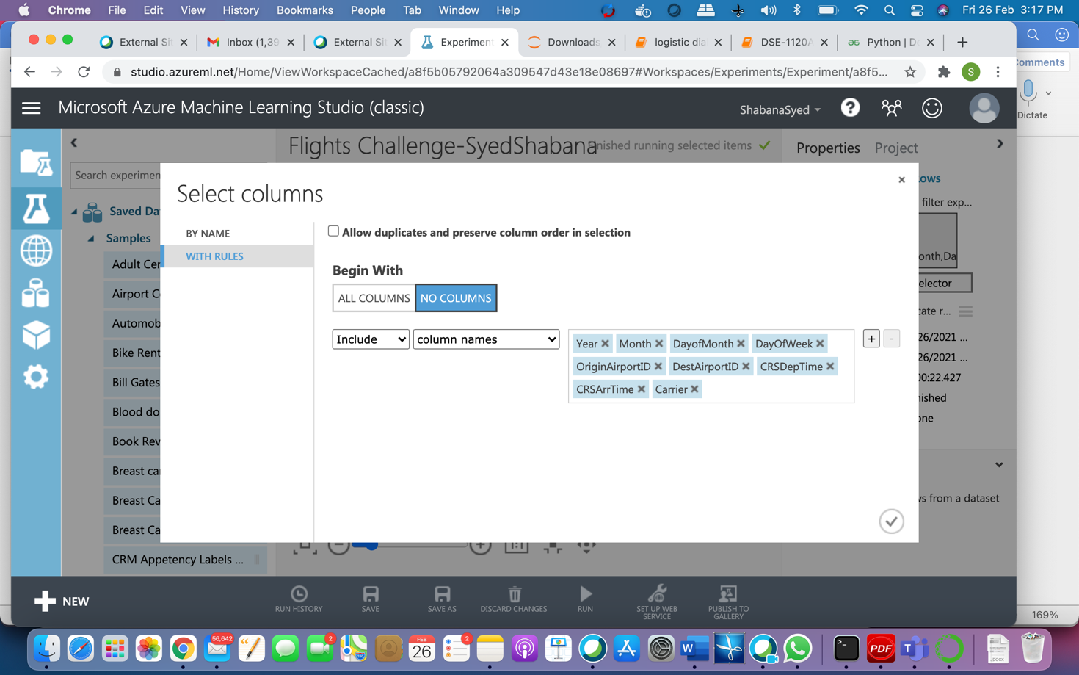

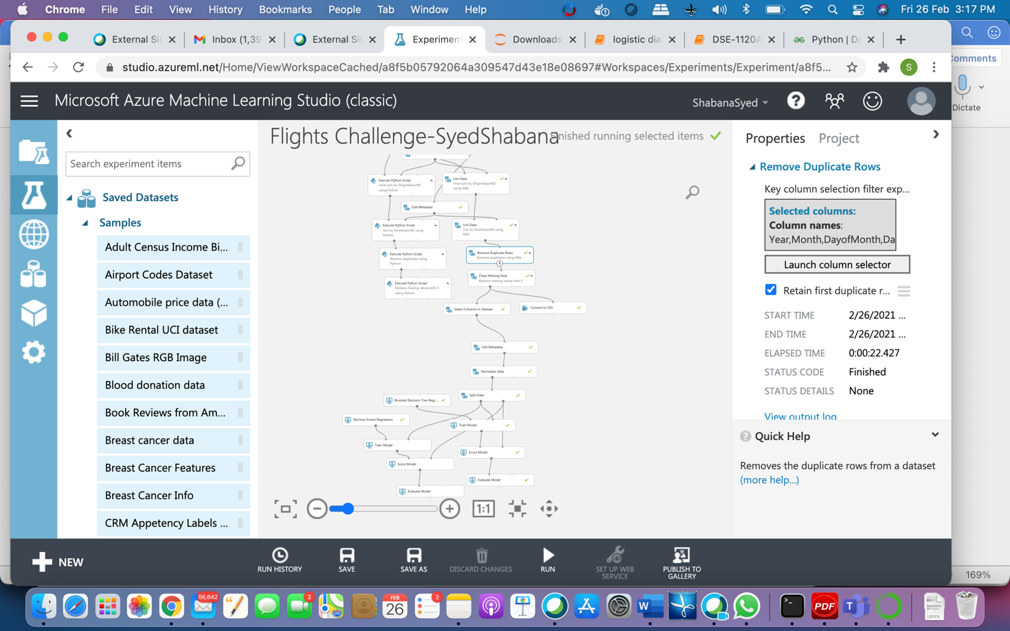

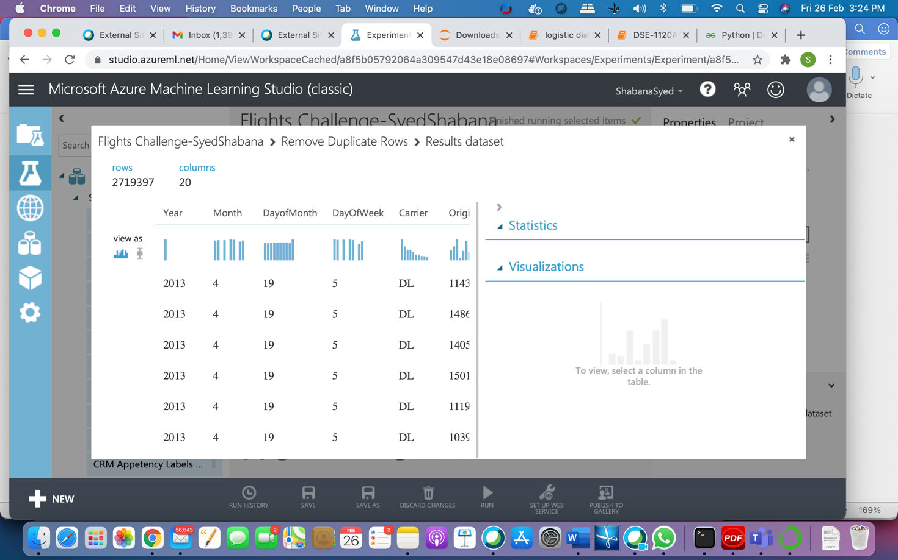

Task 2:

In this step we added clean missing data to the model to handle the missing values. Here from the screen, we can see ArrDelay field have 29030 missing values. So, for this purpose in this step, we are replacing missing values from ArrDelay and DepDelay fields with 0.

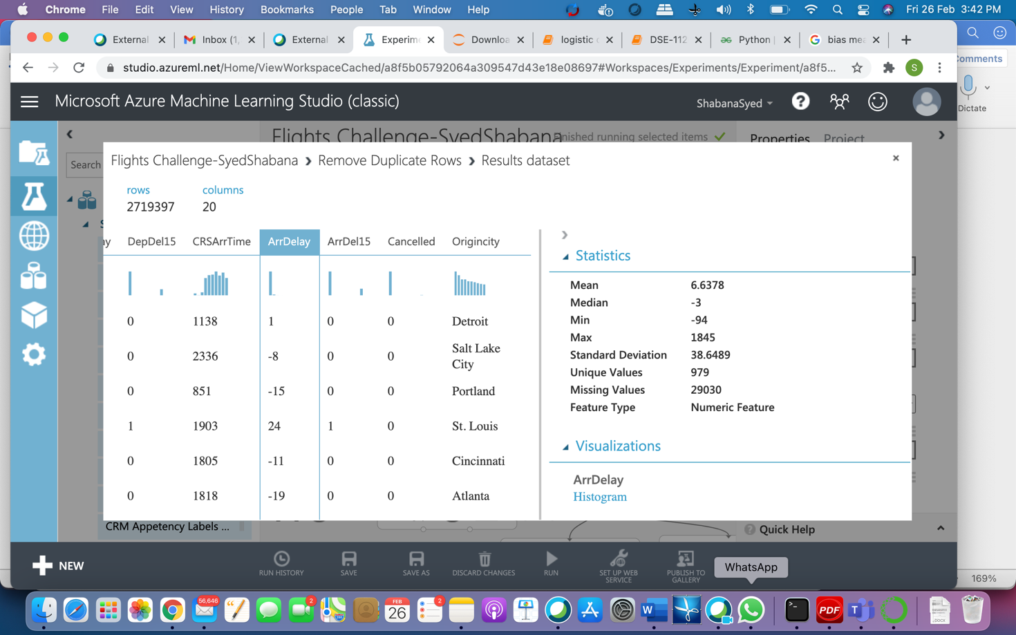

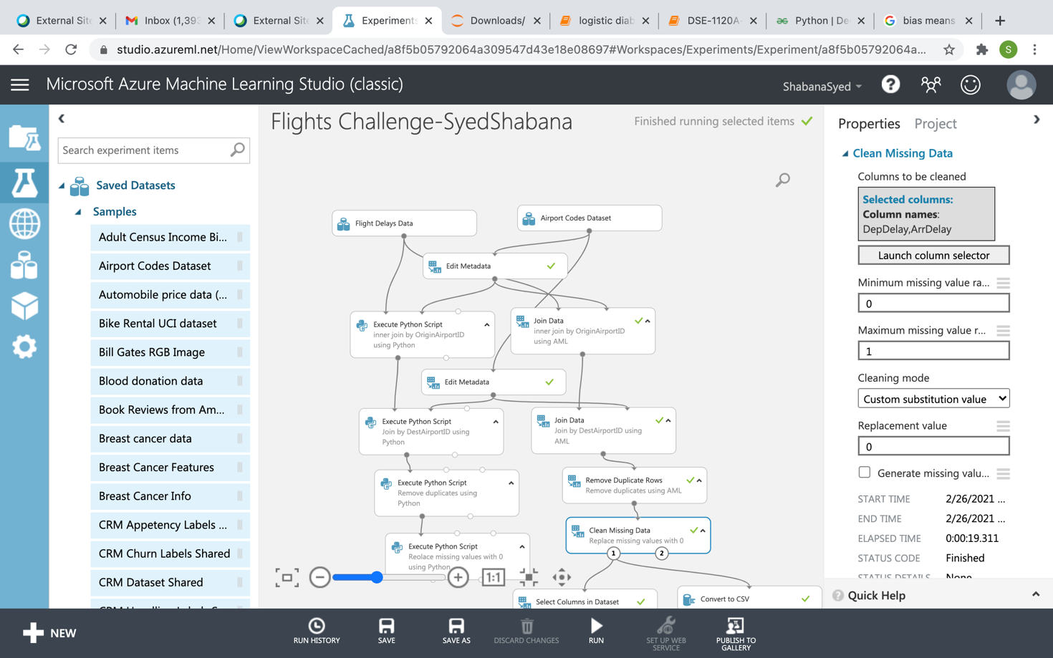

After successful execution of clean missing data, we can see ArrDelay column have 0 missing values.

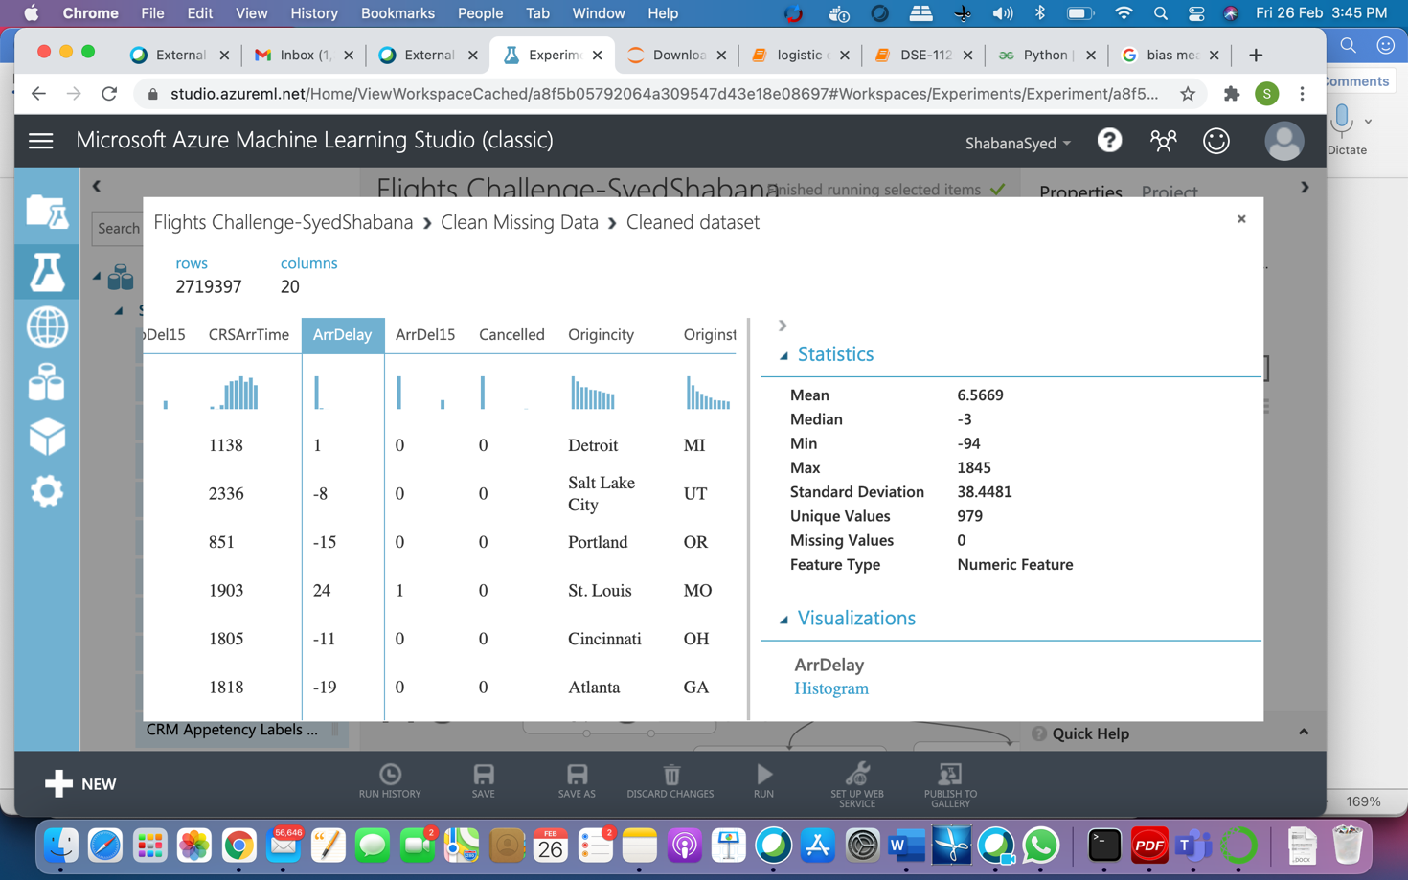

**Task 3:** 

How many rows remain in the dataset?

Ans:2719397

2.What is the mean value of ArrDelay column?

Ans. 6.5669



1. Screen-shots of each task of Activity 6

Task1: By using Convert to CSV file in the model downloaded the resulting dataset to my desktop and performed below activities in Jupyter using that data. We are using by using Python I wrote code to visualize data. Here by using describe function displayed the mean, Standard deviation, max, min, Q1, Q2, Q3 values.

count 2.719397e+06

mean 6.566923e+00

std 3.844812e+01

min -9.400000e+01

25% -1.100000e+01

50% -3.000000e+00

75% 1.000000e+01

max 1.845000e+03

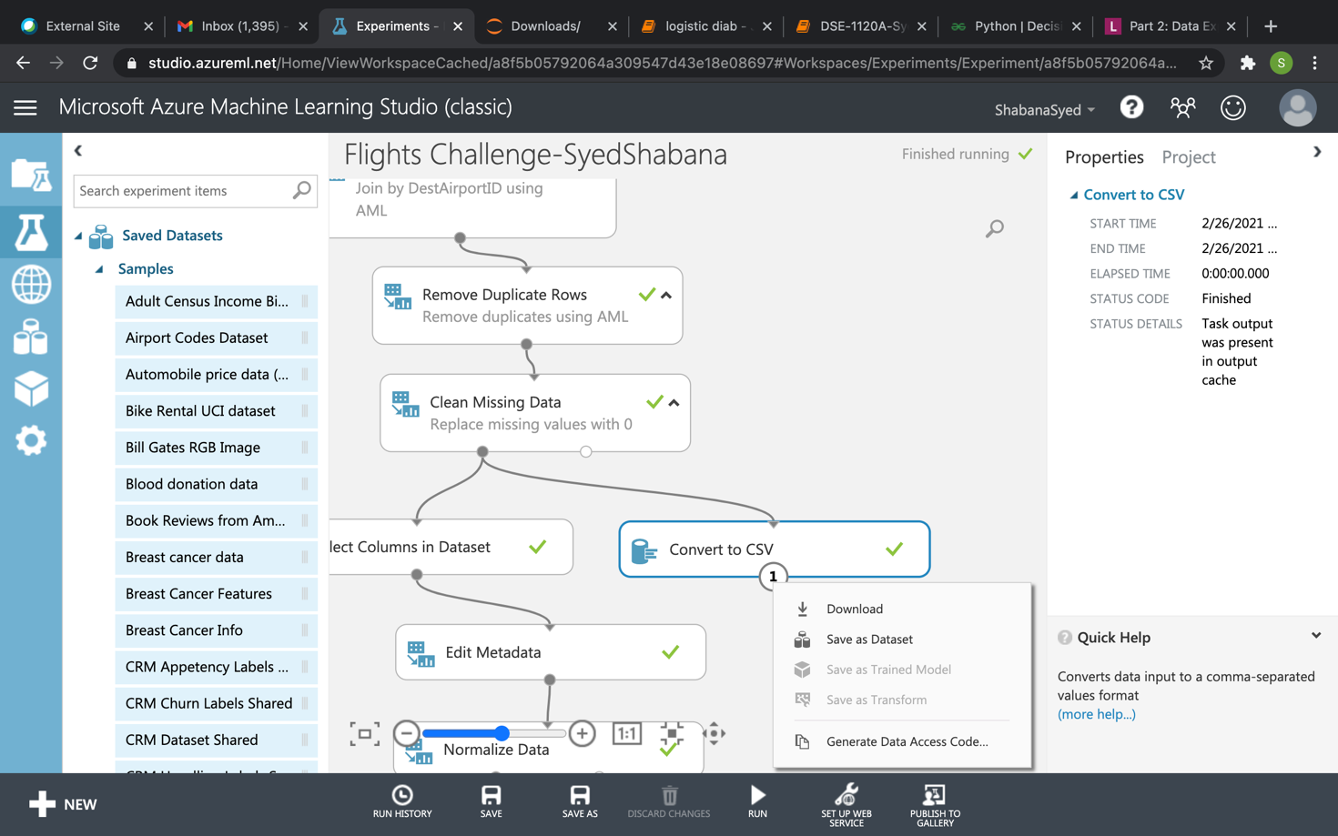

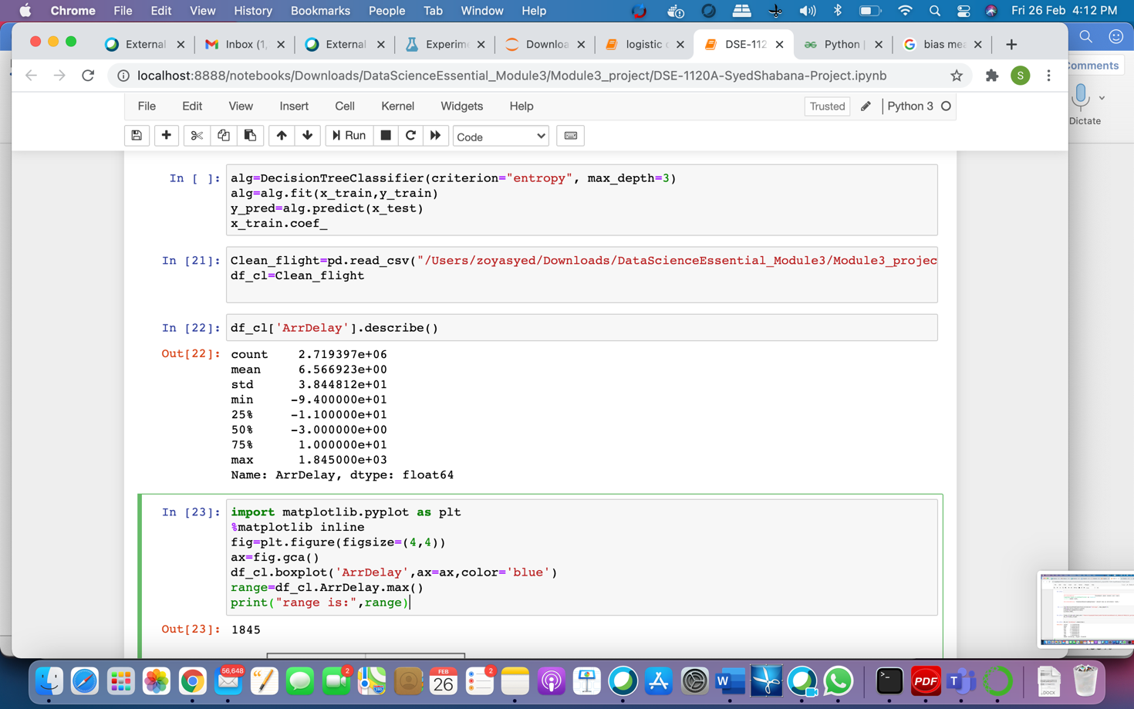

1. Screenshots of each task of Activity 7

Task2:

Plotted box plot and Histogram on ArrDelay field. We can see from the graph that

* The median, first quartile, and third quartile are all fairly close to 0, indicating that most flights arrive close to their scheduled time. There are some flights that are delayed for 2 to 3 hours also. We can see the outliers also from this box plot.
* The range of arrival times ranges extensively, with some flights arriving as much as 1500 minutes late.
* In the next step we plotted Histogram to see the distribution. From the histogram we can clearly see that the histogram is right skewed. So, there is a higher range of values for late flights than for early flights.

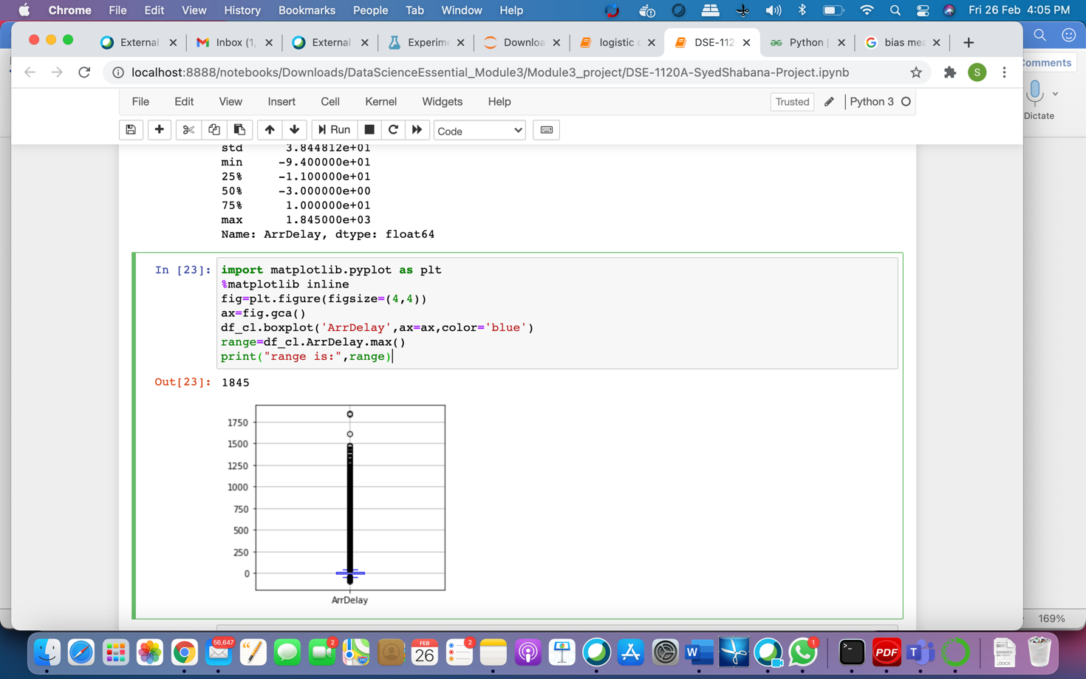

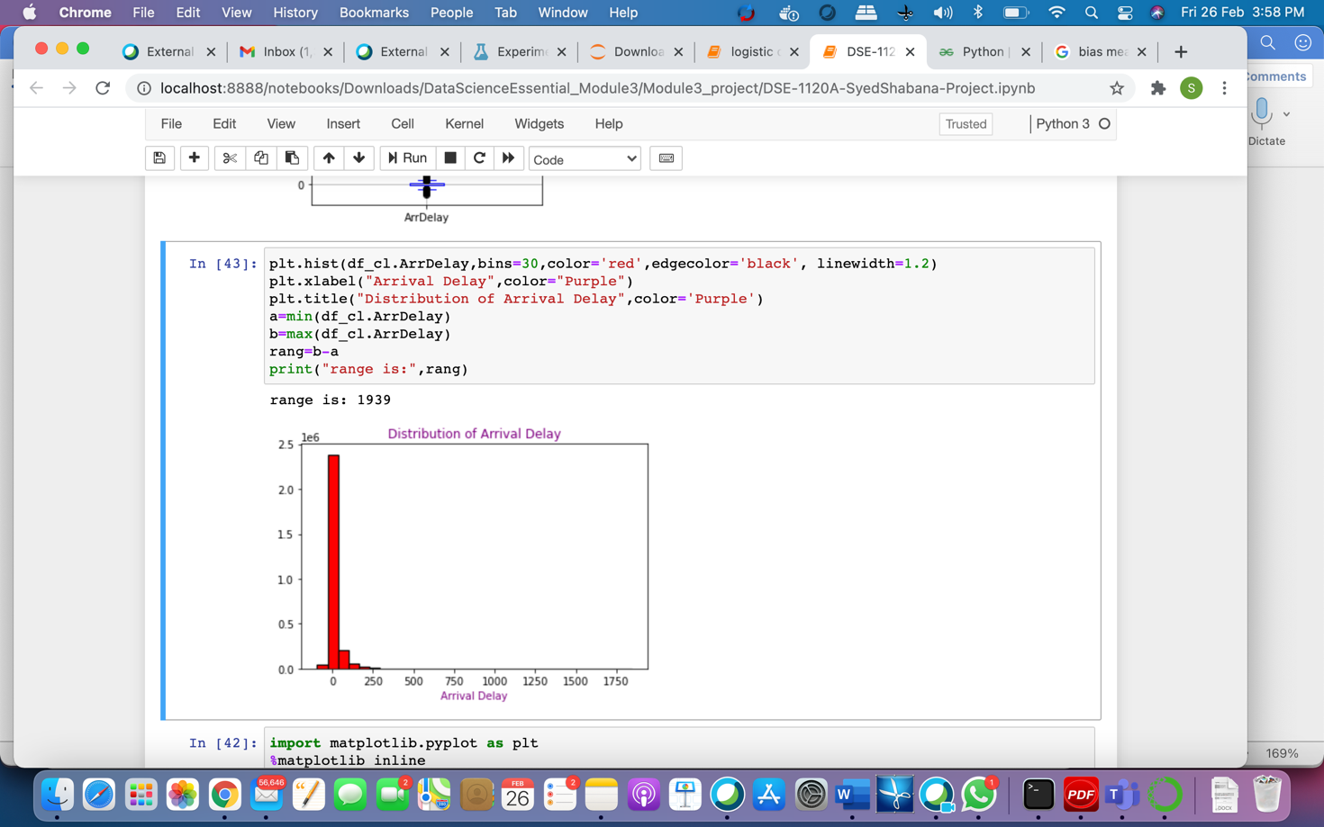

**Task3:**

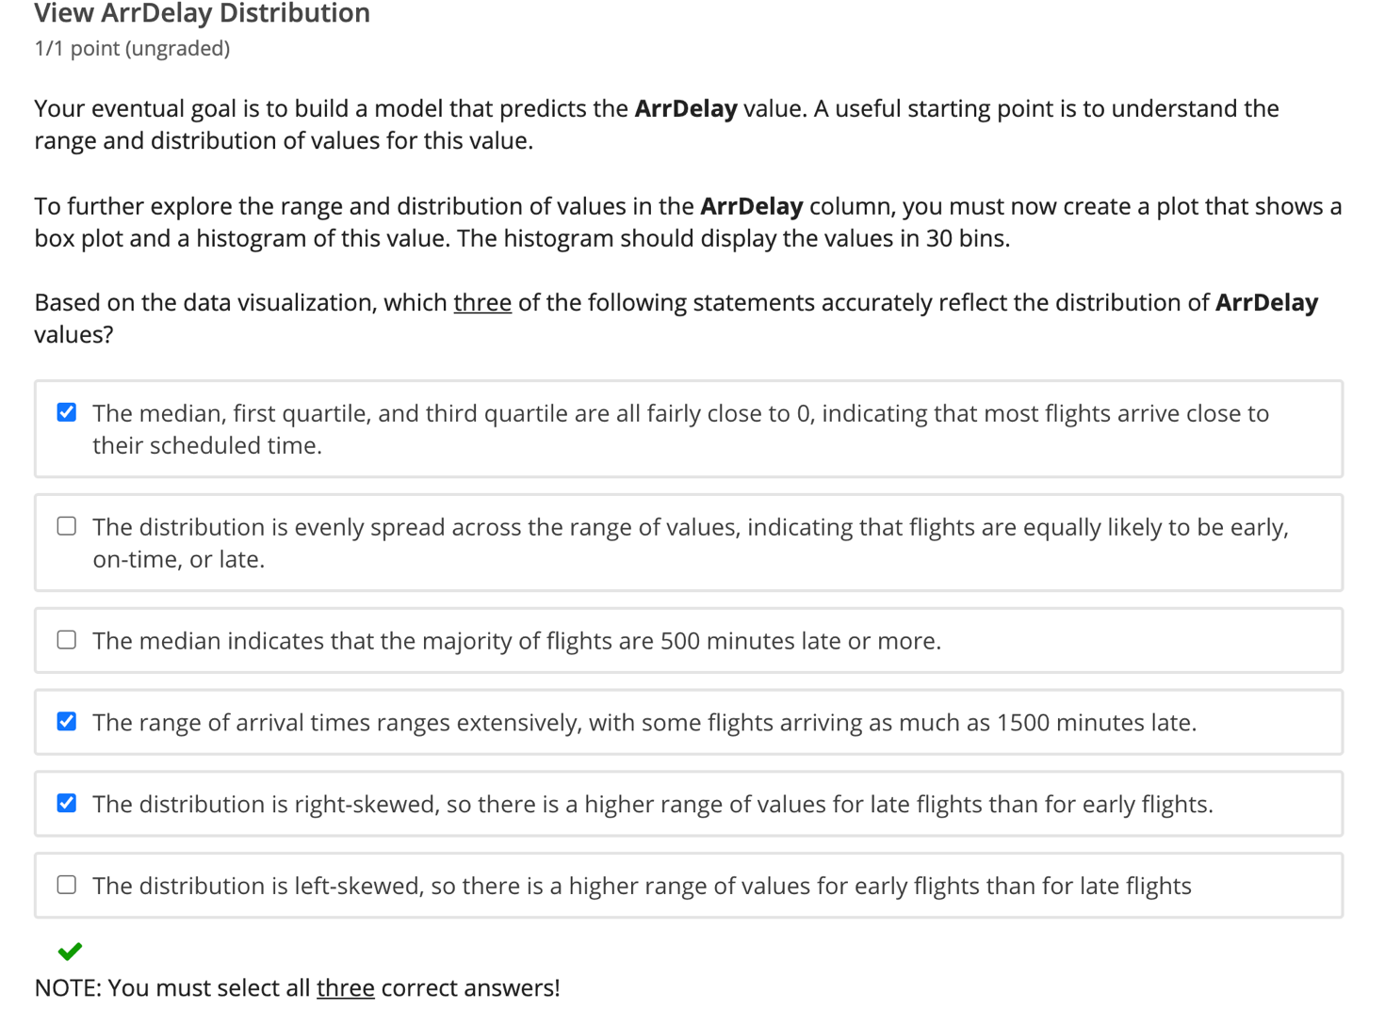

1. Screenshots of each task of Activity 8

In this step plotted histogram for numerical columns conditioned by ArrDel15 field.

* DepDelay -How many minutes flight departed delay
* CRSArrTime -Scheduled Arrival time(24 hours)
* CRSDepTime -Scheduled DepTime
* DayofMonth -Which day in month
* DayOfWeek -Which day in the week
* Month -Which month

Observations:

* Here we are checking Arrival delay is 15 mins late or more than 15 mins delay as per scheduled time and in which day in month delay is mostly happening these types of conditions can be visualised using conditioned Histogram.
* Here in the first graph more flights arrived within less than 15 mins than flights arrived more than 15 mins.
* Late flights tend to have arrival delay more than 15 mins

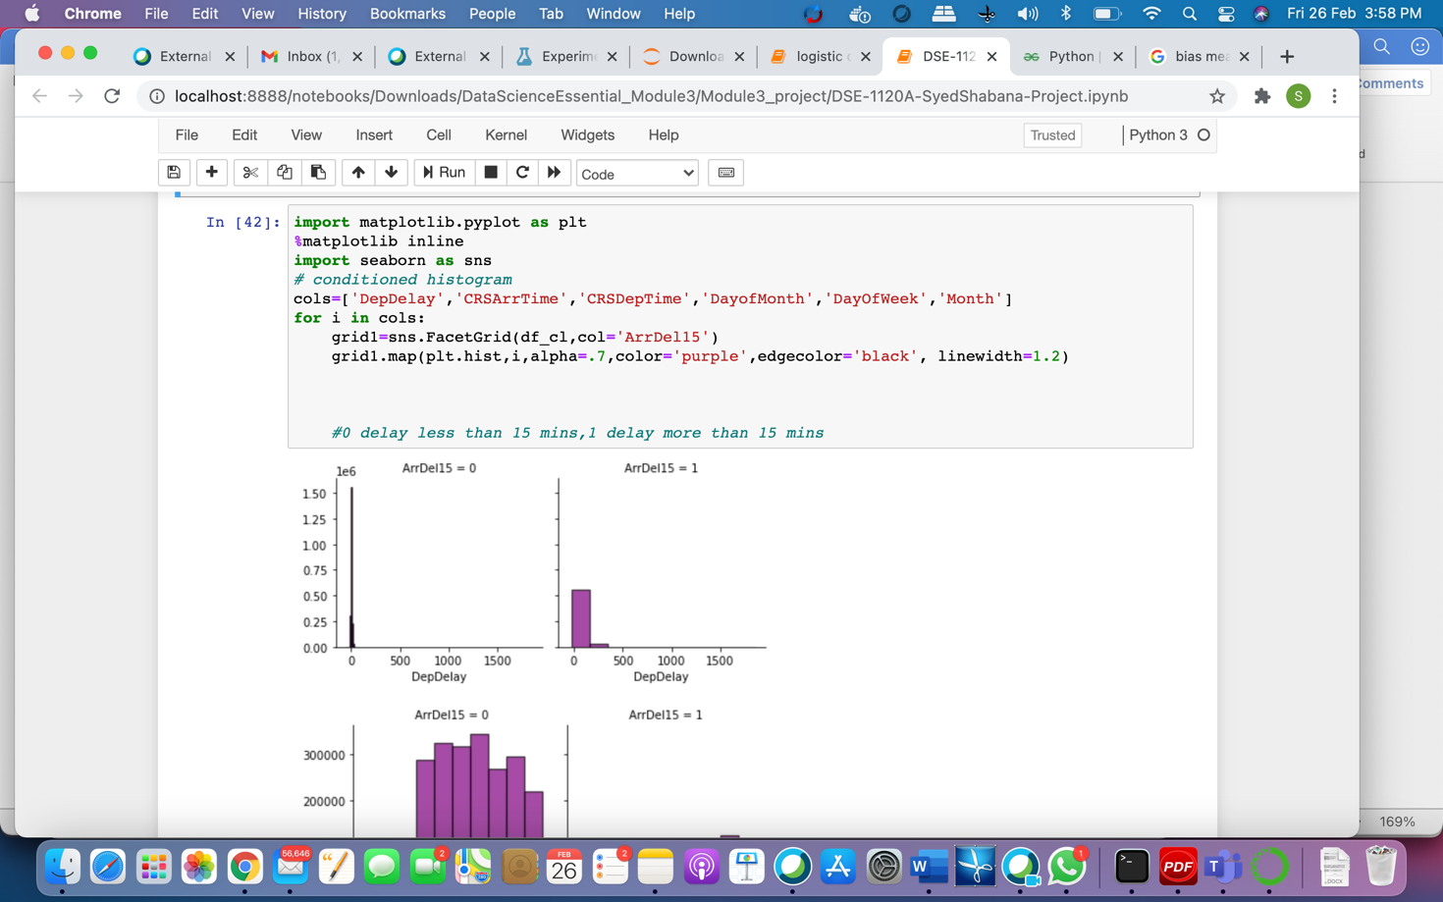

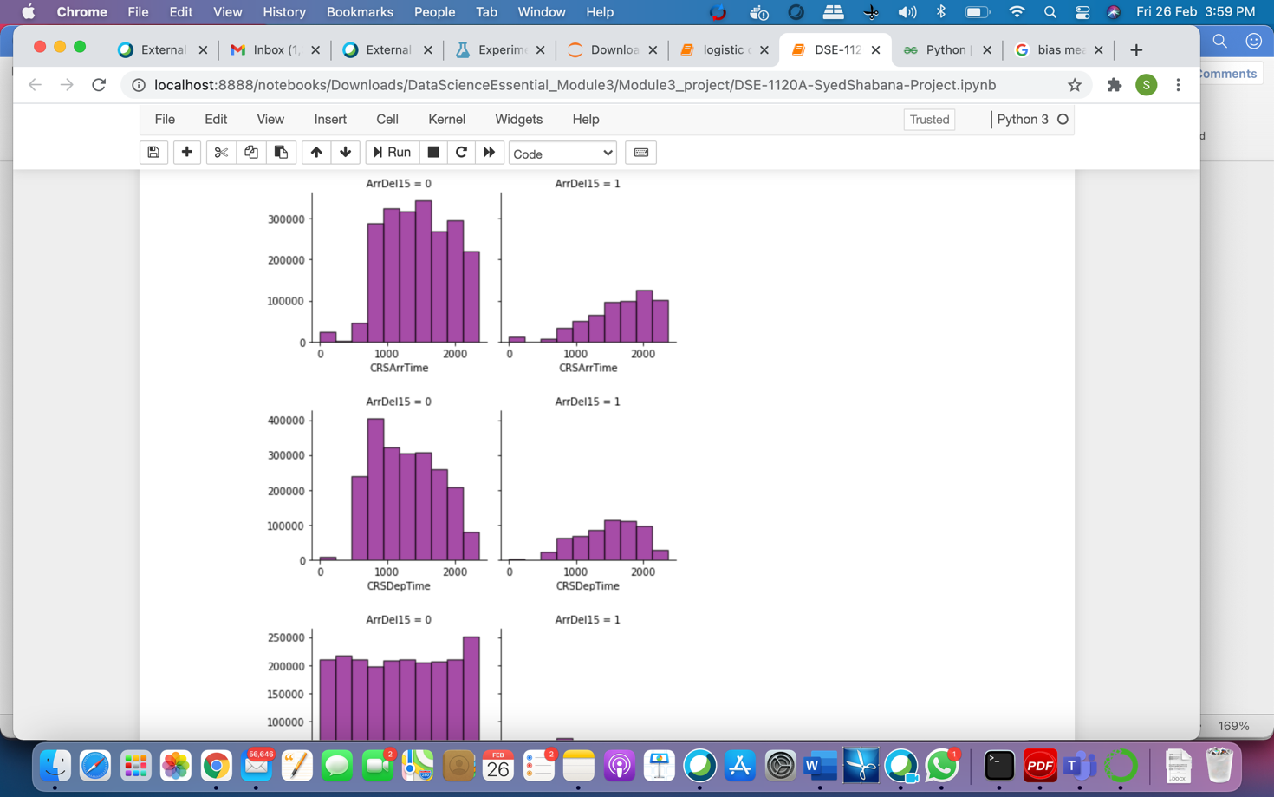

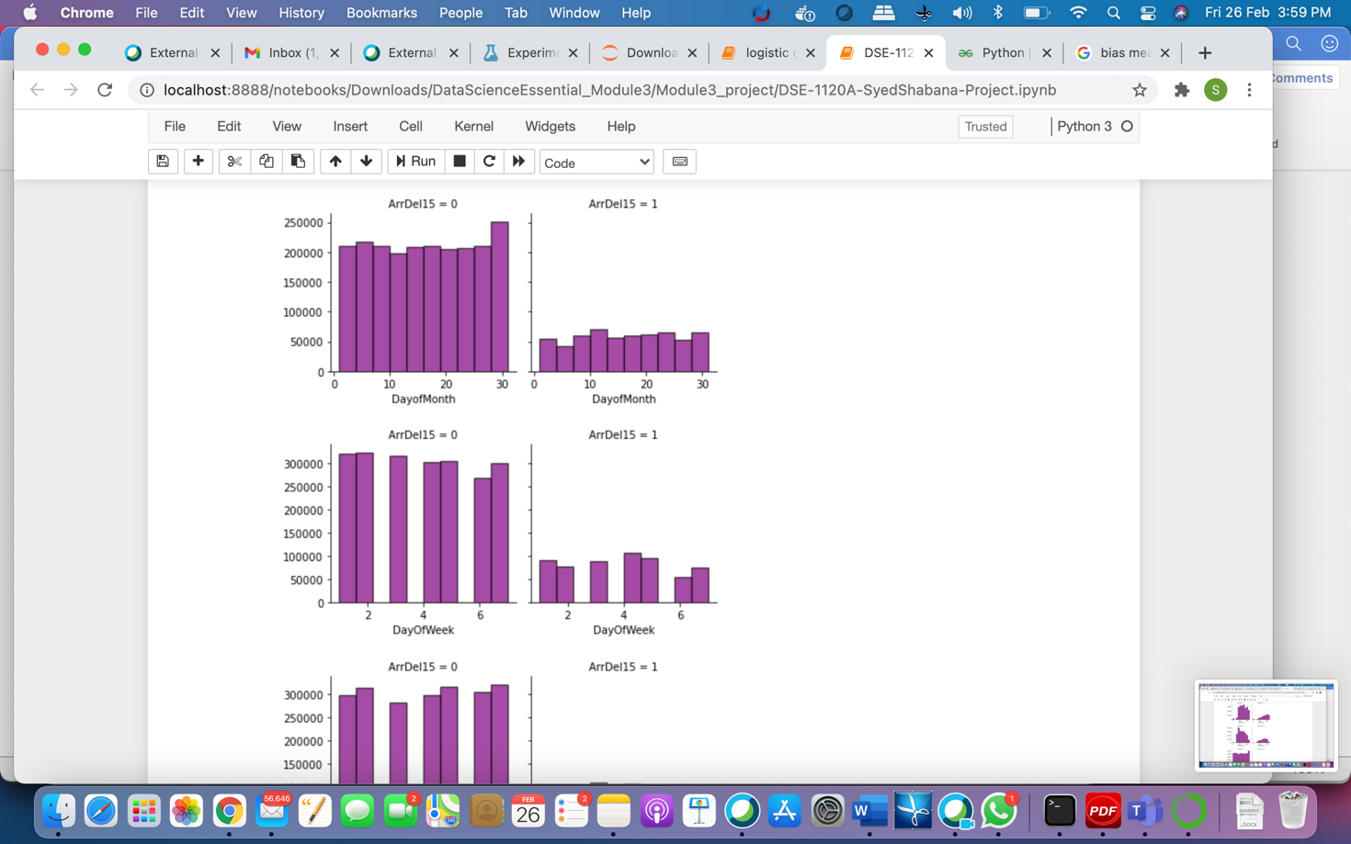

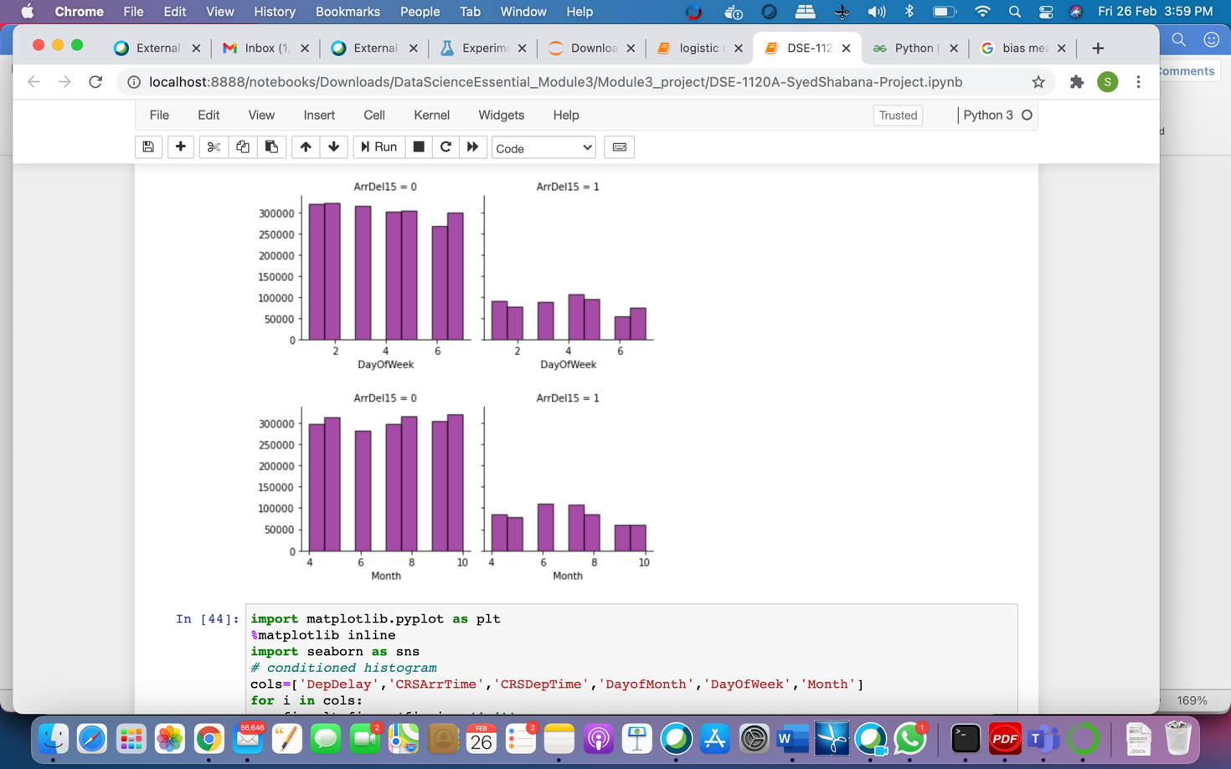

Task2:

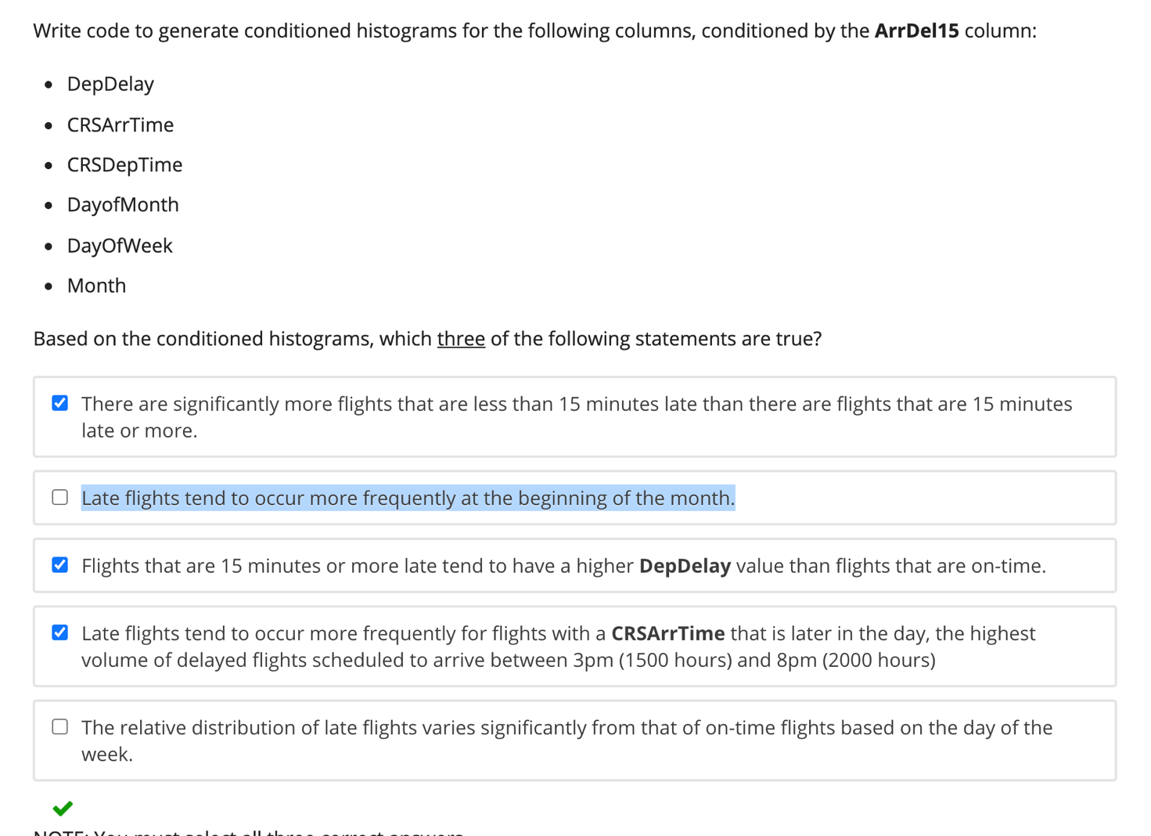

1. Screenshots of each task of Activity 9

Task 1:

In this task wrote a code to plot conditioned scatterplot for the below columns, conditioned by ArrDel15 column using 2 colors for values of 0 and 1 for the below columns

|  |
| --- |
|  |

* DepDelay
* CRSArrTime
* CRSDepTime
* DayofMonth
* DayOfWeek
* Month

Observations:

* From the below graphs there is a strong positive correlation between Arrival and Departure delay.
* Most of the flights that depart early in the morning have early arrival or less than 15 mins delay in the Arrival.

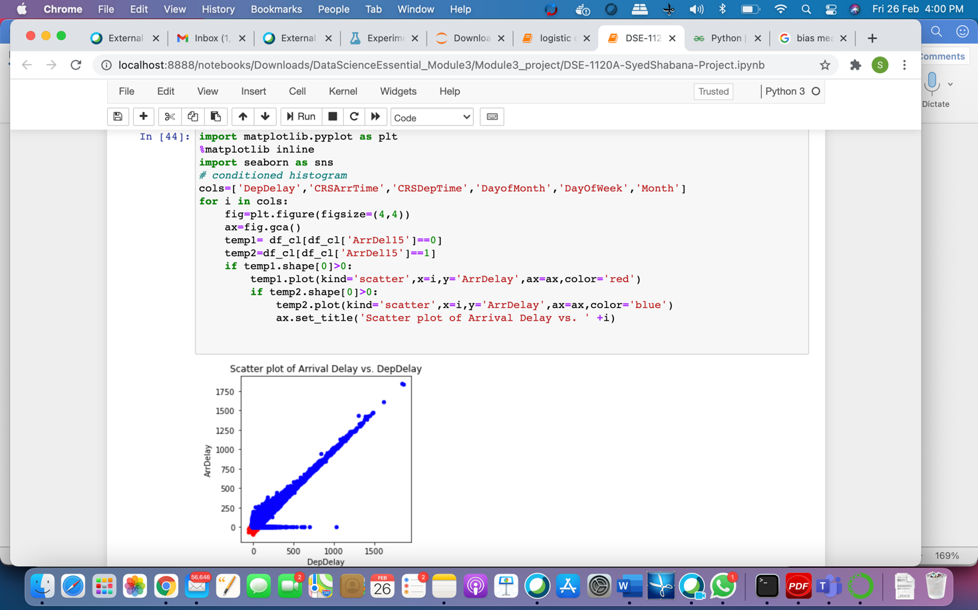

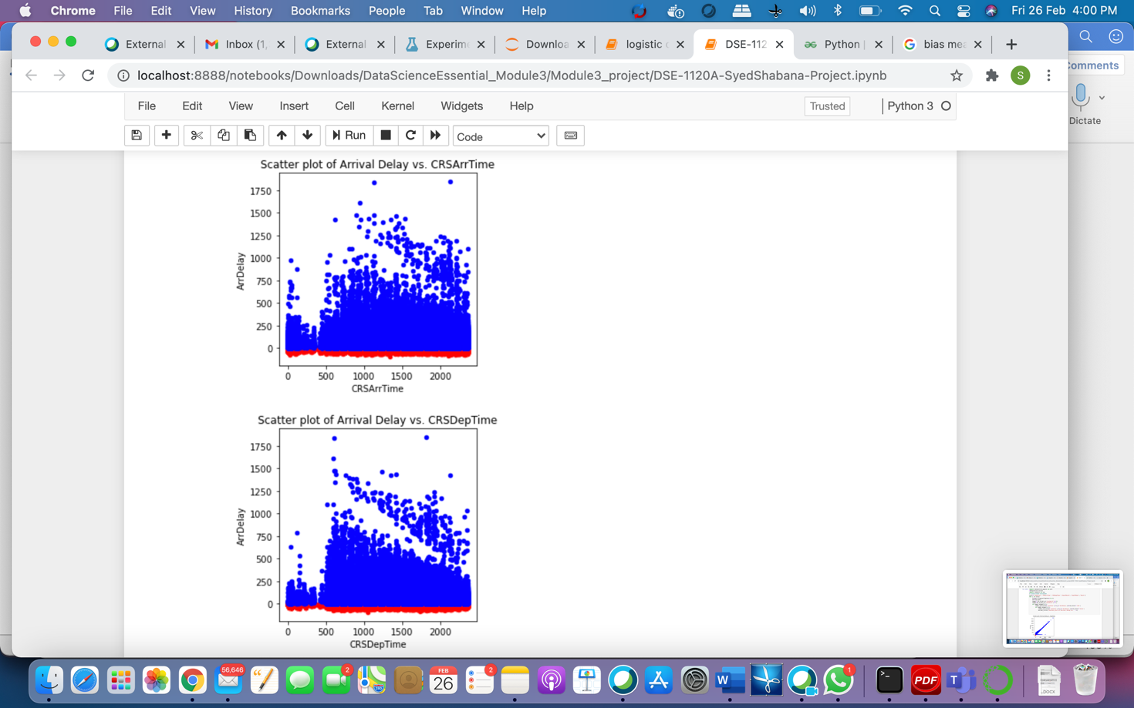

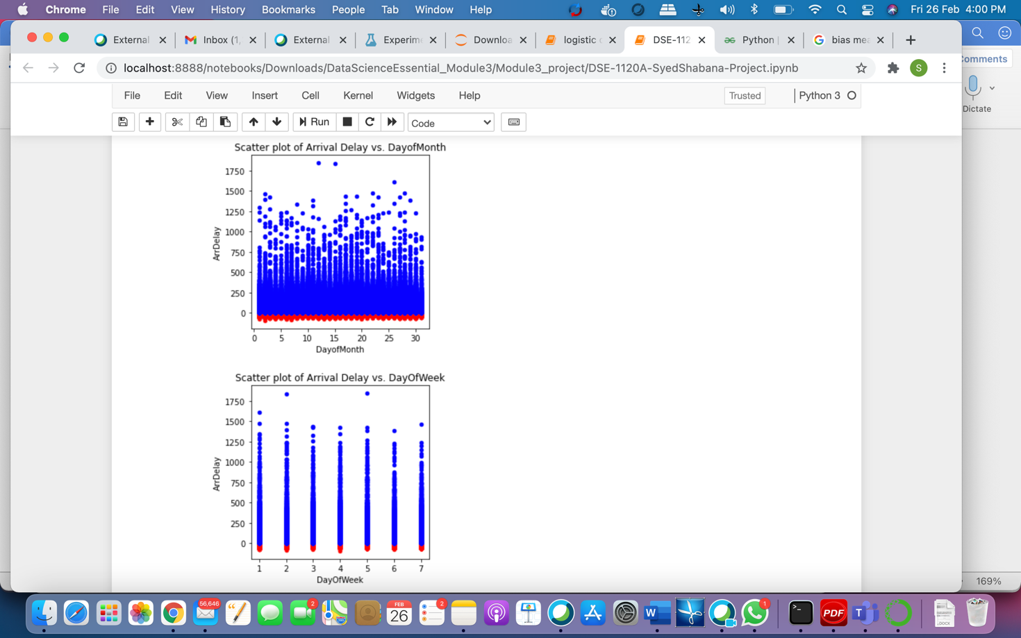

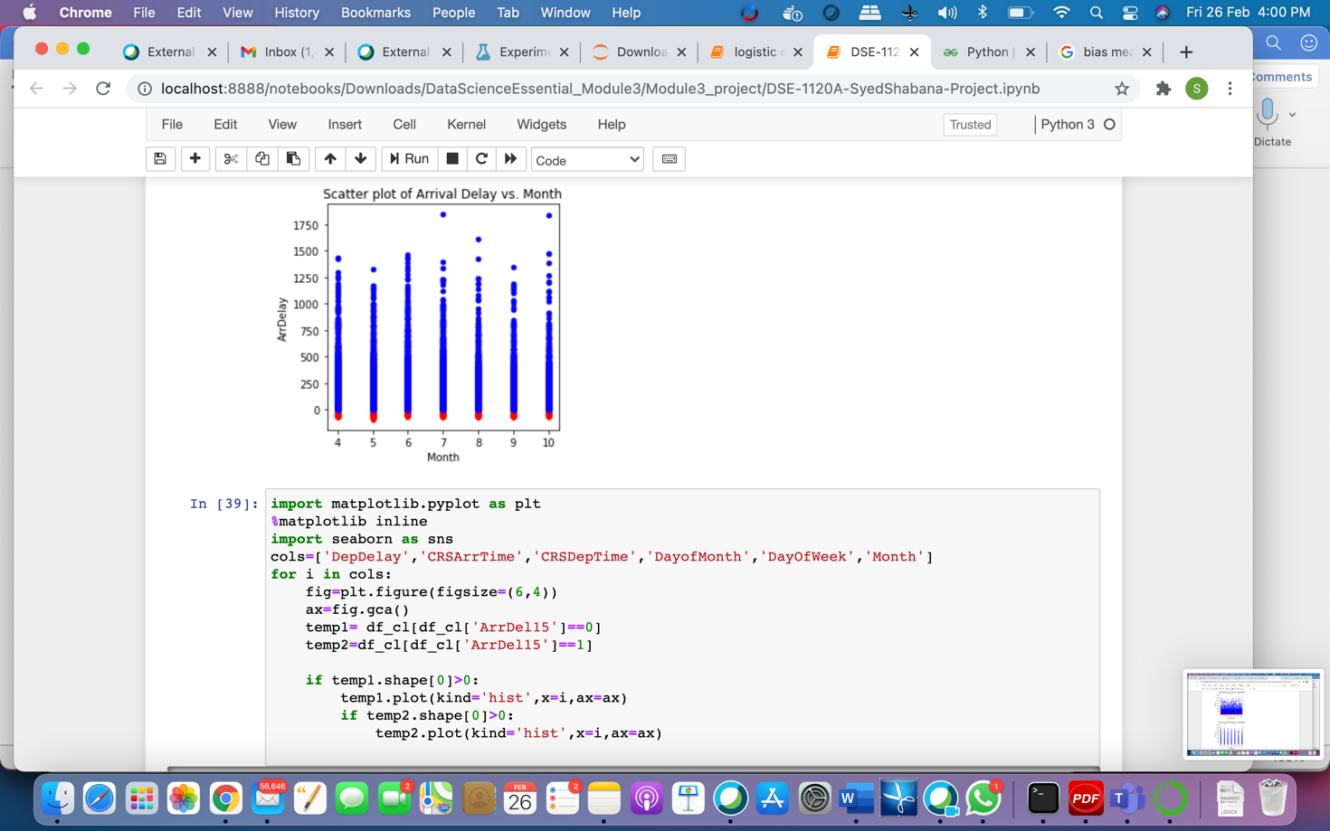

1. Screen-shots of each task of Activity 11

After cleaning the dataset next created machine learning model to predict the arrival delay based on the features that have been explored in the visualization.

* In this step added select column to the model. Here selecting the columns that are used for prediction from the cleaned dataset. These are the the columns that are selected in this module to predict ArrDelay .Those features are Month, DayofMonth, DayOfWeek, Carrier, OriginAirportID, DestAirportID, CRSDepTime, DepDelay, CRSArrTime, and ArrDelay columns
* Next added Edit metadata to the model to make OriginAirportID, DestAirportID and carrier as categorical.
* In the next step added Normalize data to the model. If we see the data CRSDepTime , CRSArrTime , DepDelay field values are not in the same scale for the above features. To make the values to same scale we are applying Z-score to normalization method.
* After normalisation added split data to the model. In this step divided the data as 70% for training and 30% for testing.
* Applied Boosted decision Tree regression to the train model. Here we have ArrDelay depend on different conditions. So used Boosted decision tree. First used Decision Tree Regression to the model and checked. Compared both the models.
* Next added Train model to the experiment and selected ArrDelay to predict. Later added Score model to the experiment .After the successful execution checked scored label added to the resulting dataset.
* At last added Evaluate model to the dataset. And then executed the model. Checked the result.

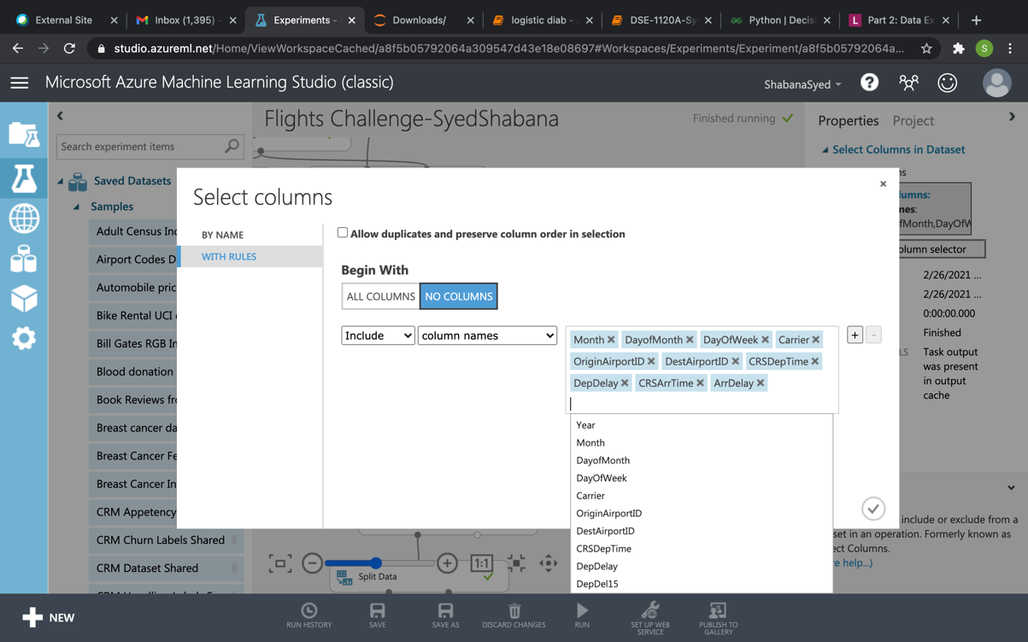

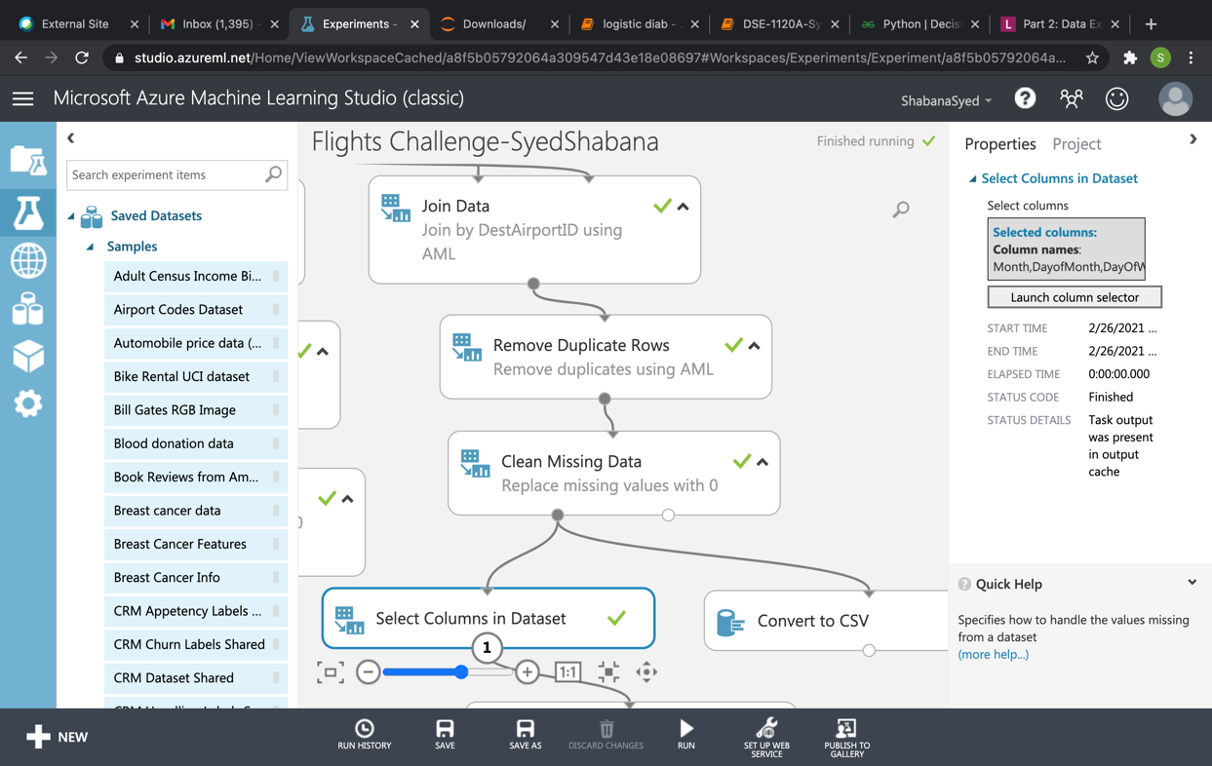

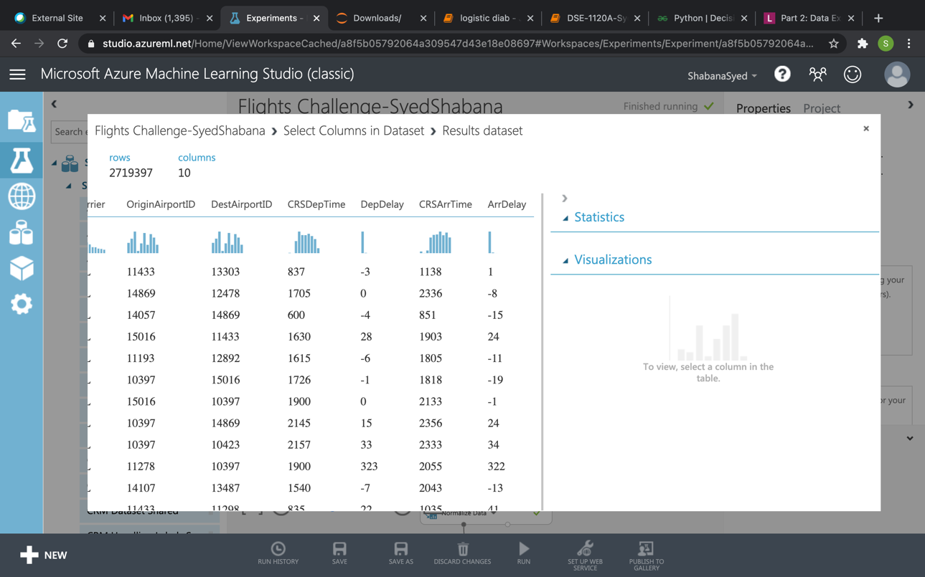

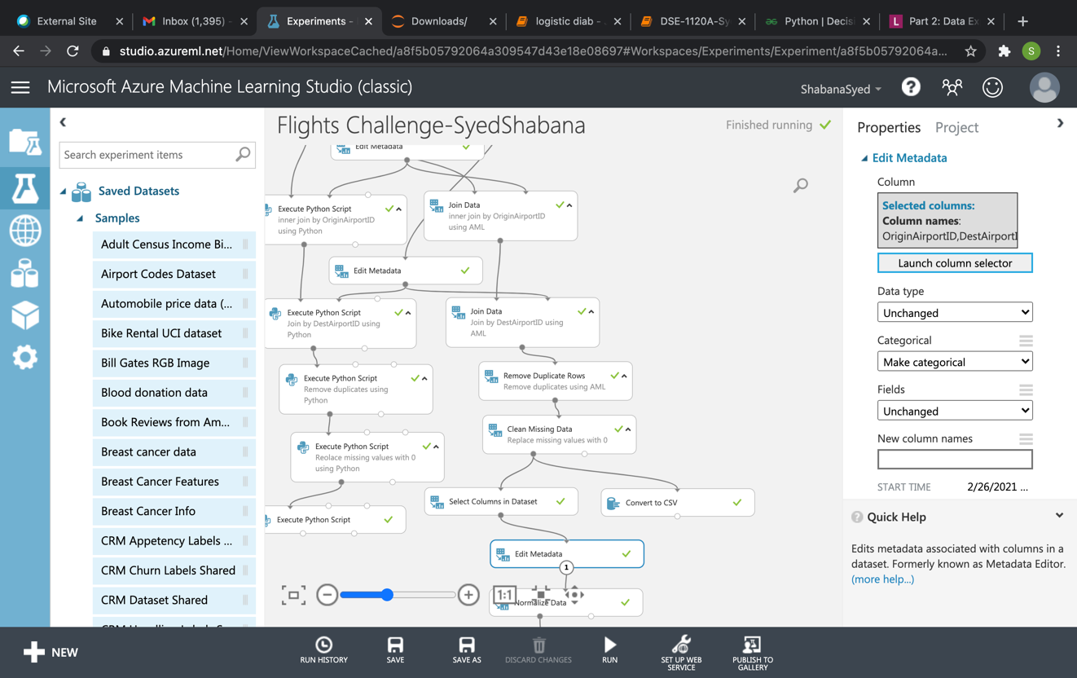

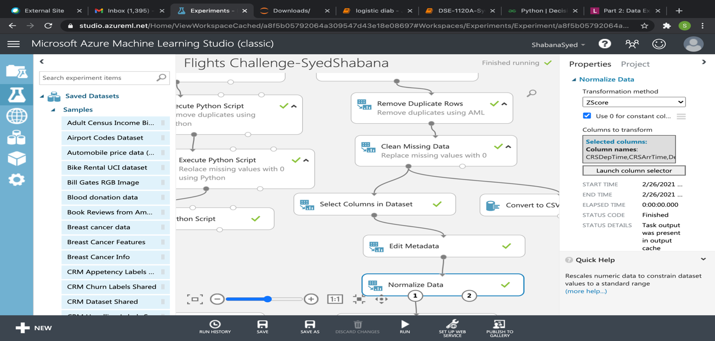

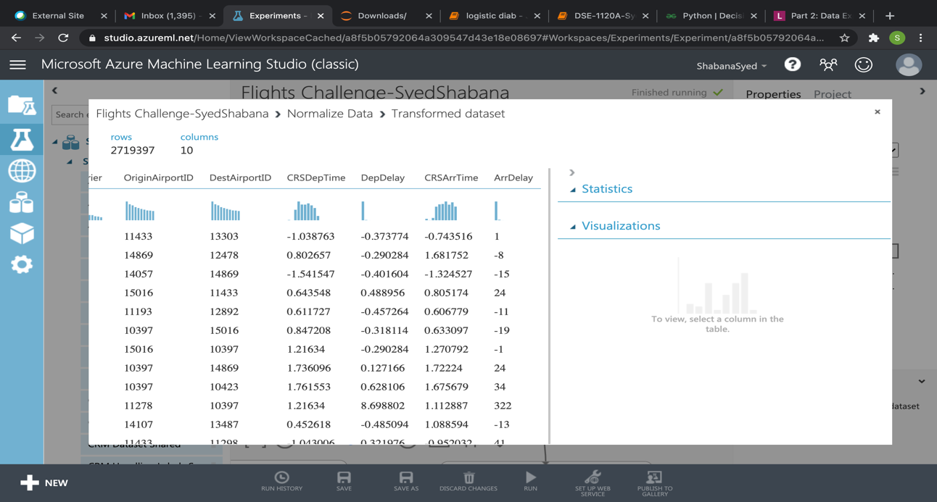

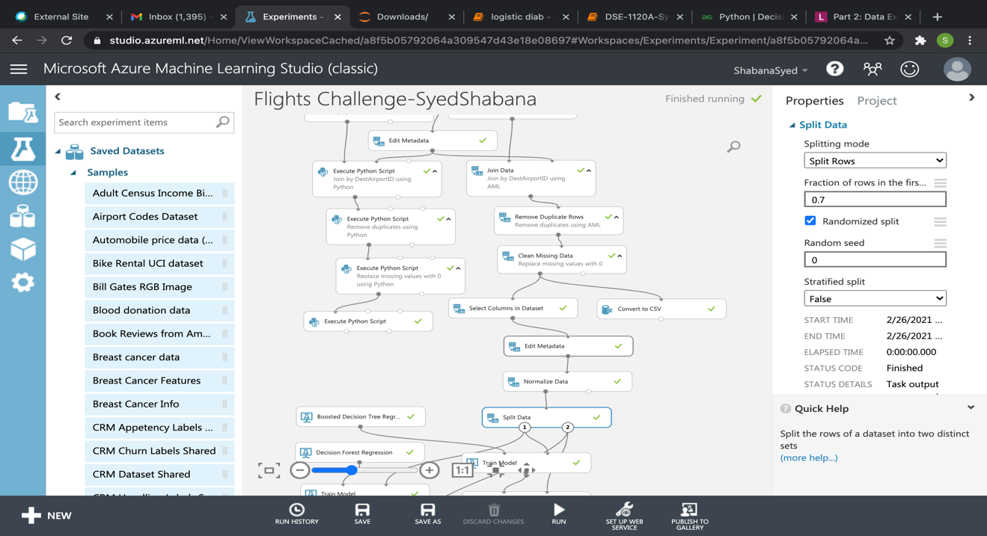

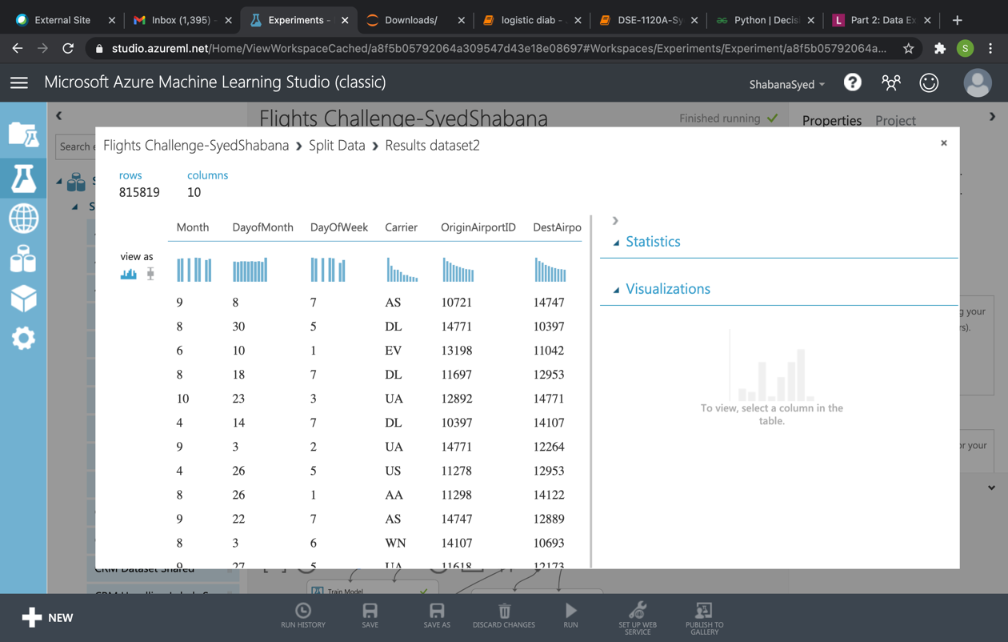

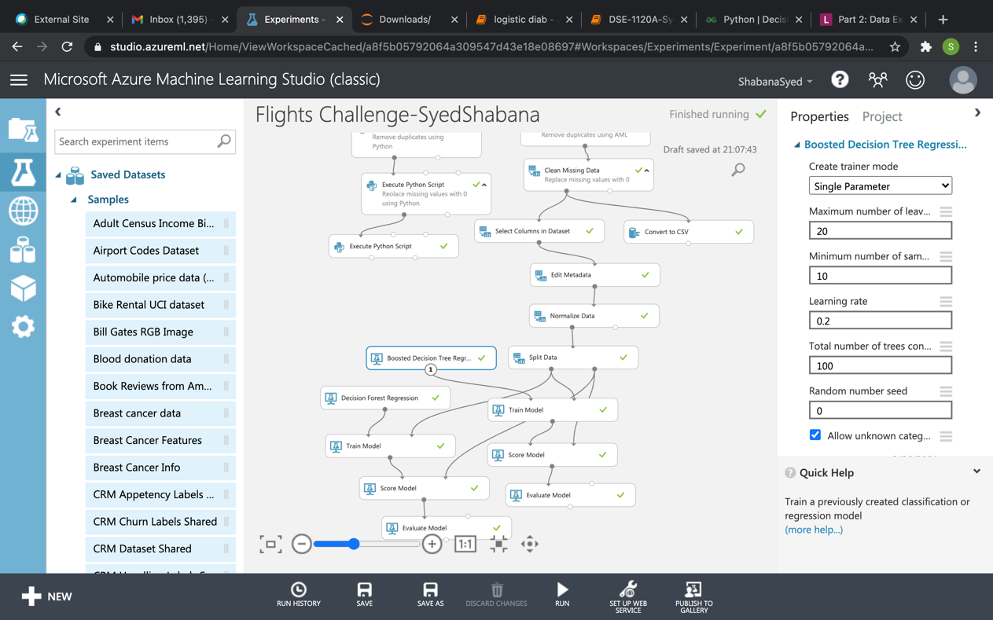

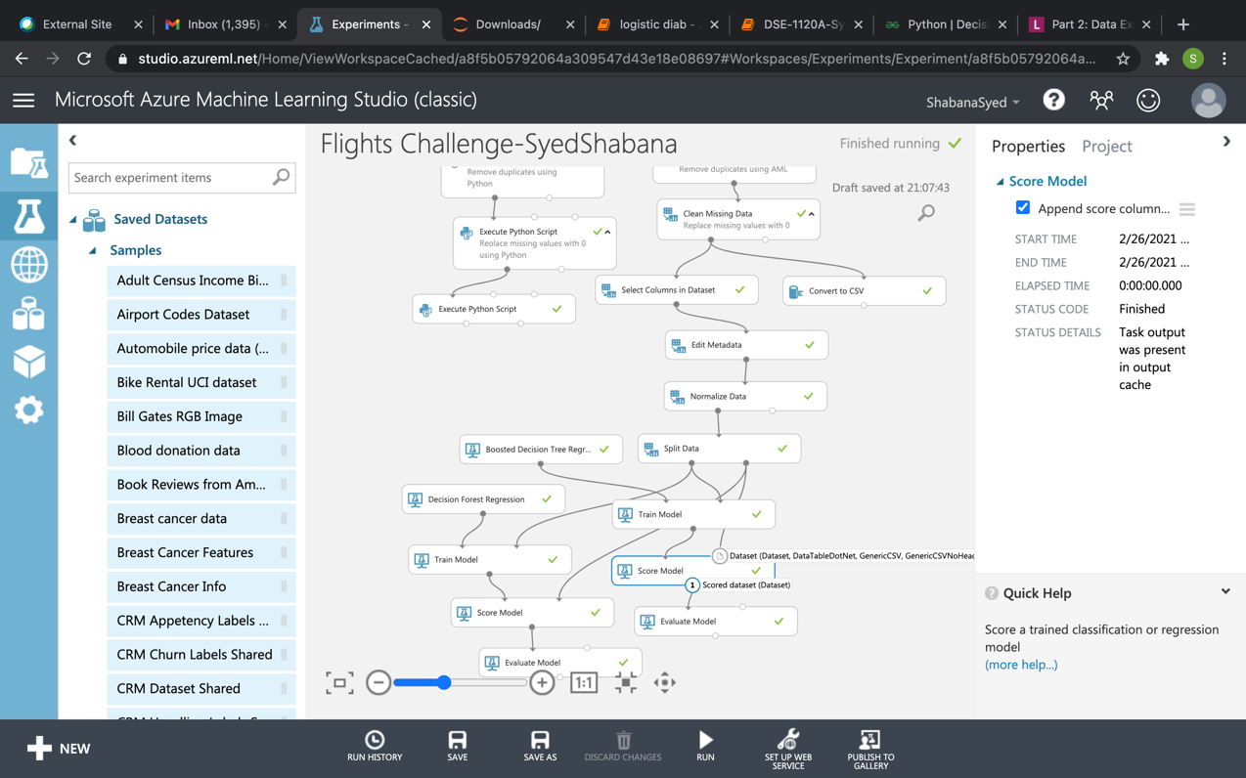

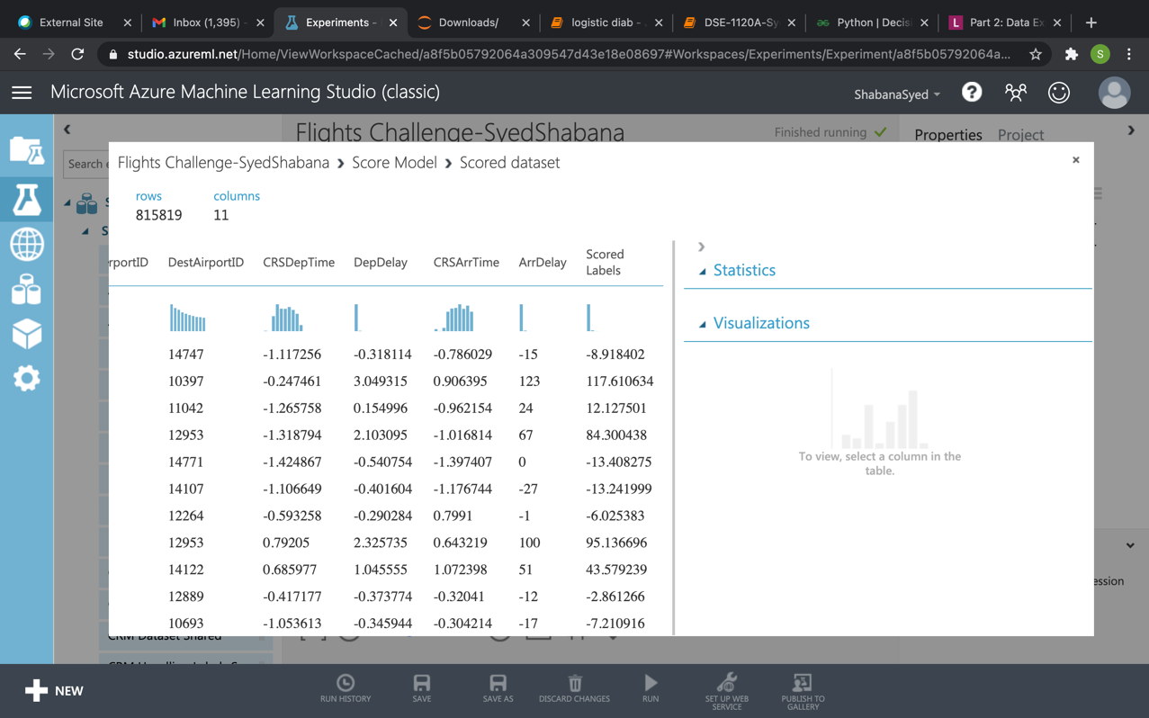

1. Screen-shots of each task of Activity 11

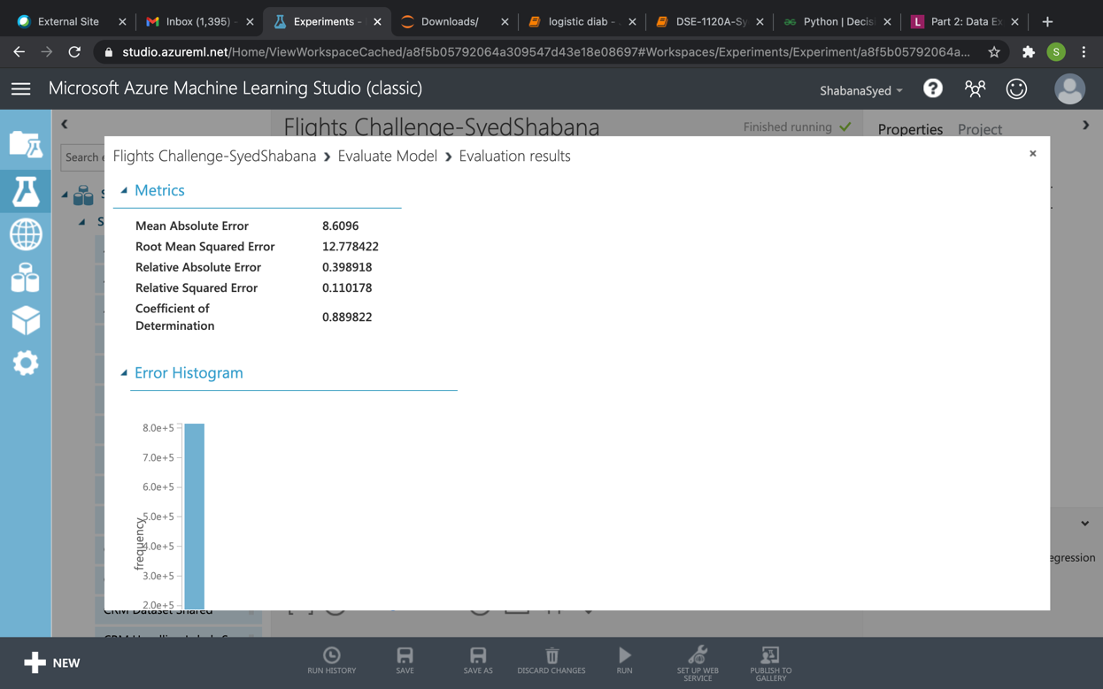

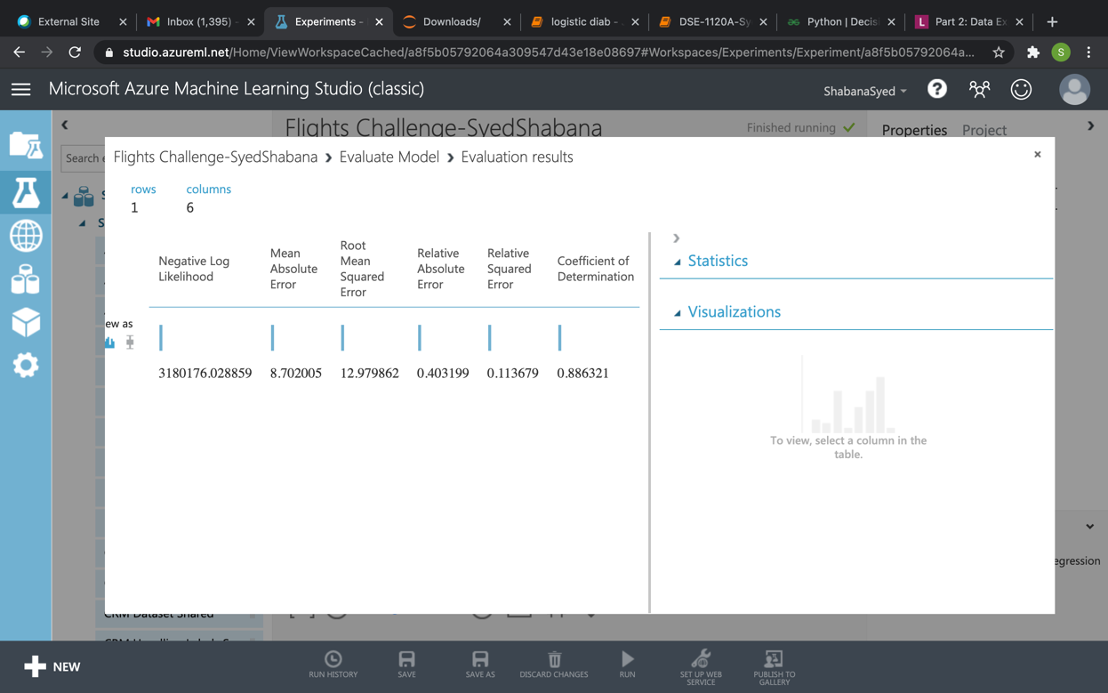

1. Screen-shots of each task of Activity 12

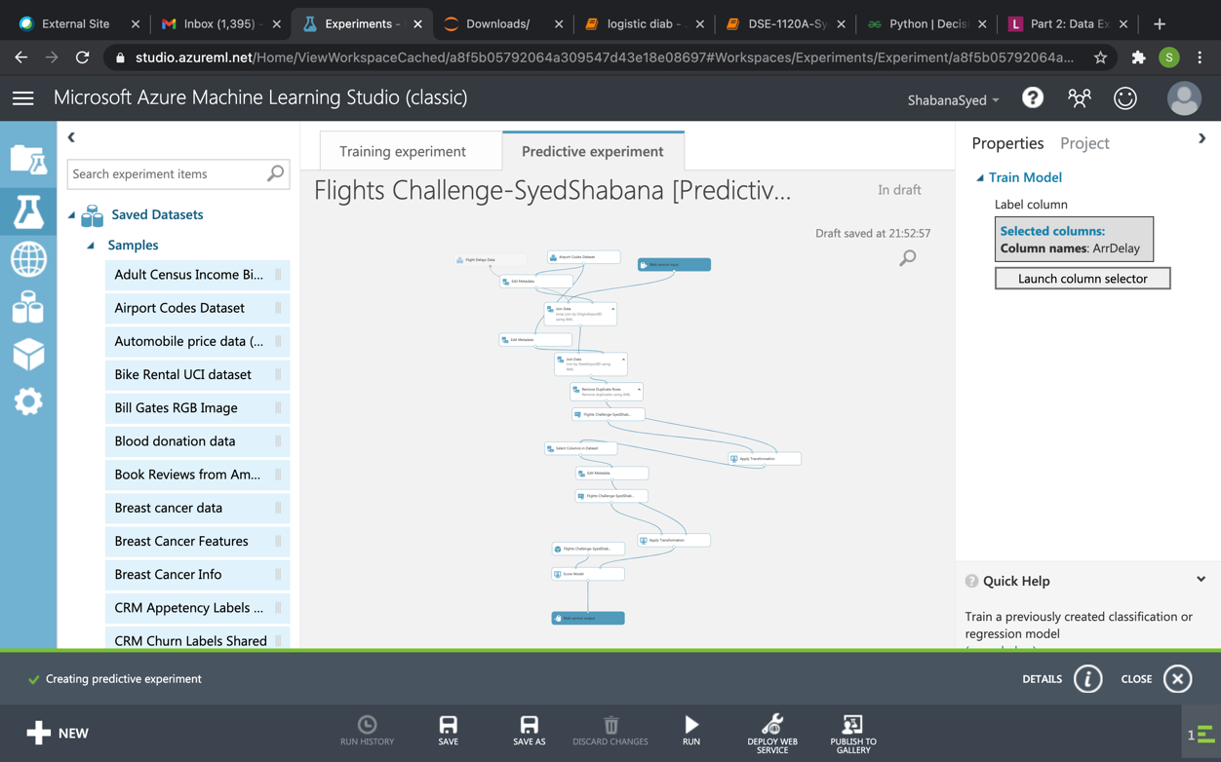

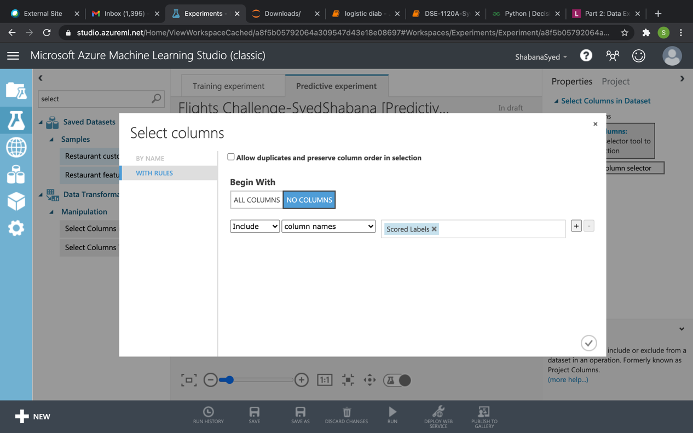

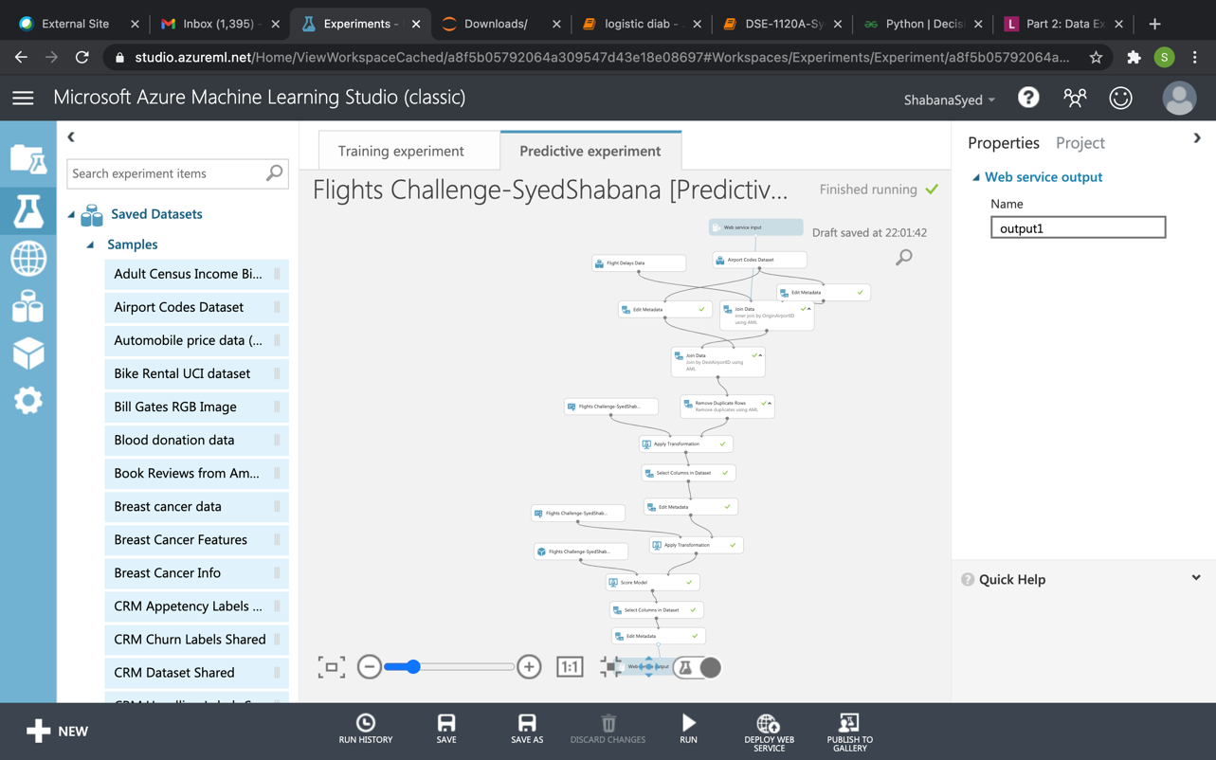

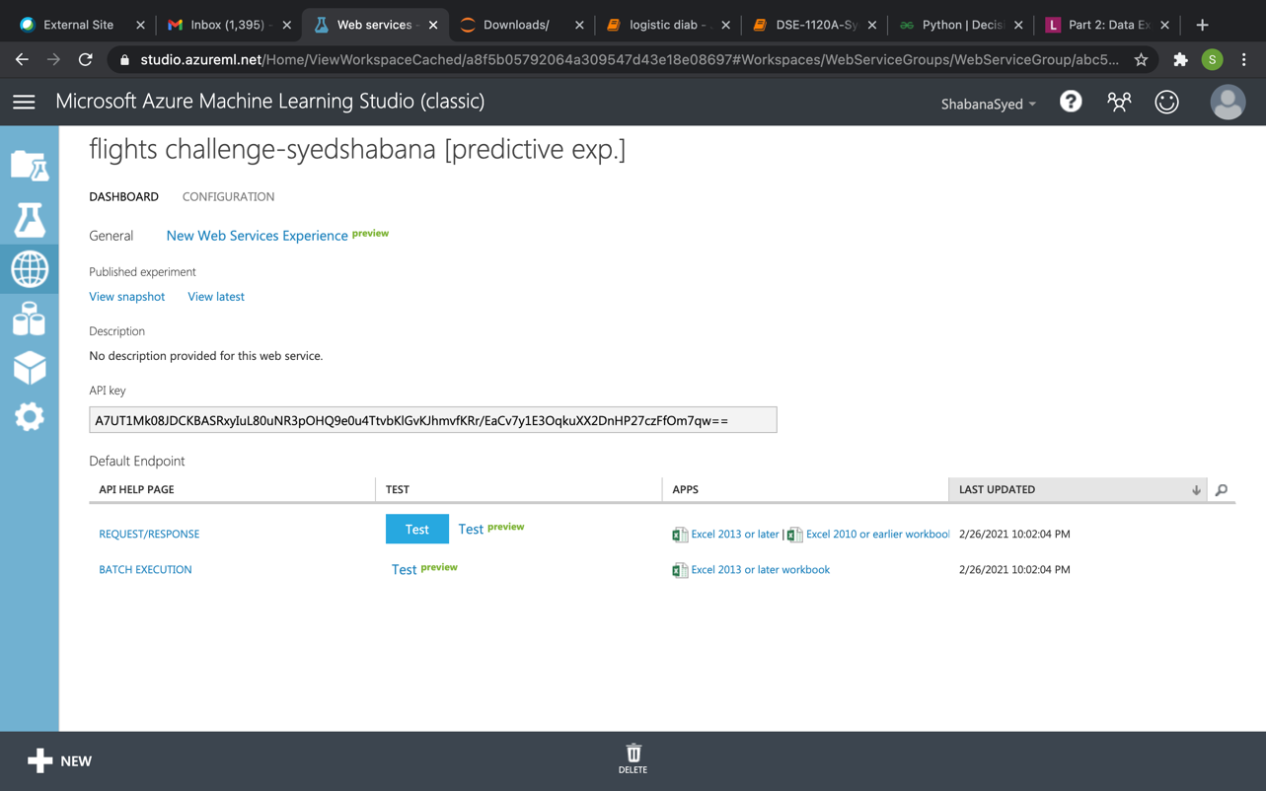

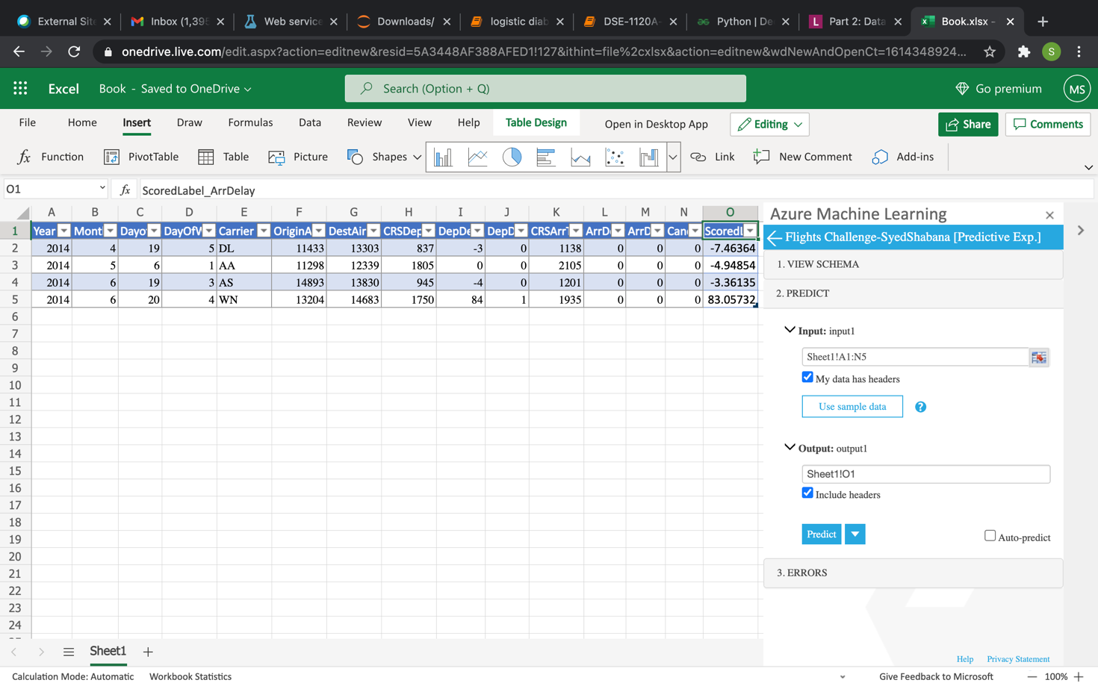

Annexure:

AML link:

<https://studio.azureml.net/Home/ViewWorkspaceCached/a8f5b05792064a309547d43e18e08697?#Workspaces/Experiments/Experiment/a8f5b05792064a309547d43e18e08697.f-id.9a0e379afd5d4001b84f17fa9aec388e/ViewExperiment>

Predict values in excel using web service:

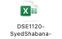

Python code for building the model and visualization:

<DSE-1120A-SyedShabana-Project.ipynb>